It is recommended to use emojis in the headlines

Make sure you utilize the headlines.

Always try to make description lengthy

Keep the description user friendly

Like we add multiple headlines this is same for description also.

So teacher was giving us insights about how different element come inside ad copy

The offers are generally come in headlines because these headlines looks bold. Ad npw

And now all depend on the call to action button

So by this way you can write the multiple ad copy by sing different ad elements

You cannot depend only on one ad

You should try that you make multiple ad copy

You cannot make ad just in fifteen minutes

From audience research, creative creation to writing our ad copy and adding element to it it takes lots of time to do it. We will have to do proper research then we will be able to write good ad copy and ad copy that actually converge.

**Lesson 38:-**

In this lesson we will learn about **What is facebook Pixel and how it works?**

There are many topics related to pixel but we will do discussion around basics like What is facebook pixel?

Why do we use Facebook pixel?

How does the facebook pixel actually look?

And the facebook pixel code or Javascript code what this actually mean

And what are the element inside it. And in what situation pixel help us.

So we will do basic description around it

In recent times because of IOS update the capabilities of facebook pixel has already been reduced

As a arketer the IOS 14 has opened many challenges. We will discuss about it later but first we need to understand what facebook pixel actually is and what he can do for us.

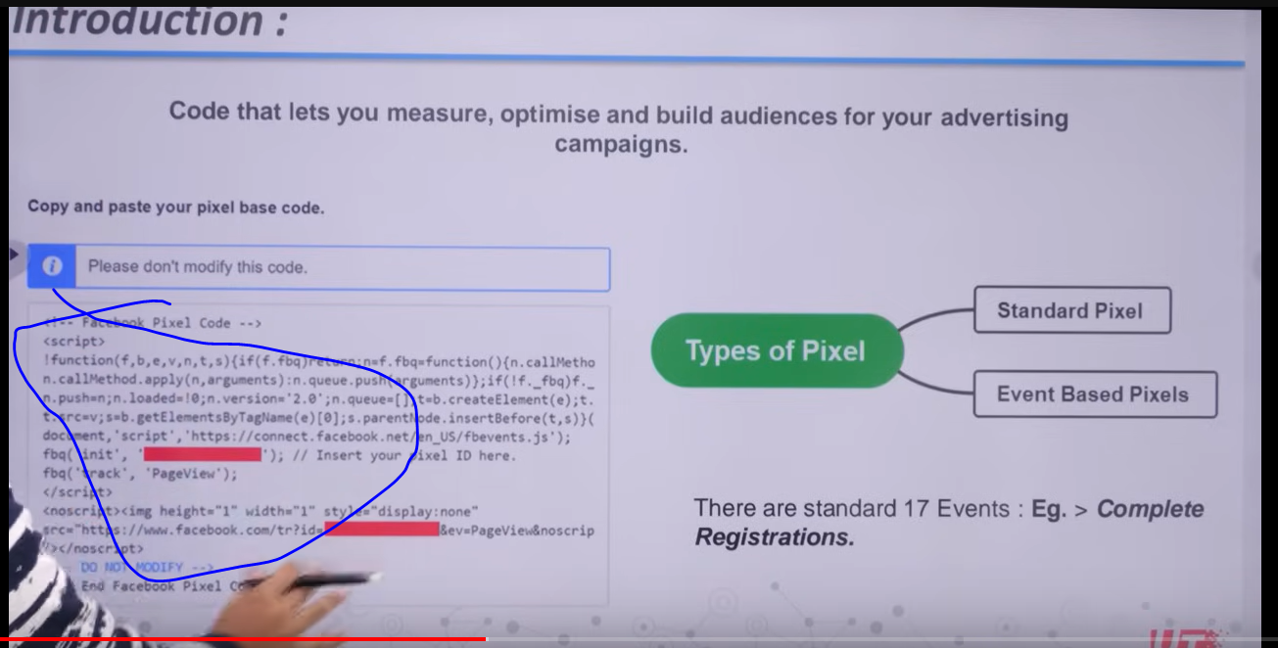

In above image you can see the java code as marked above.

This is Facebook pixel so actually Facebook pixel is actually javascript code that we add in our website

When you add it on your website what are the capabilities we get and what we can do.

Another point which is important is that when you have any ad account you have one pixel and that pixel look like javascript code

You can see two types of pixel in your ad account that is

**Standard**

**Event Based Pixels**

The standard pixel is also called base pixel

The javascript code in image is actually base pixel similarly there is some event specific pixels

Statndard Pixel only track page view

It will be alble ot tell you that one page is viewed and what page is viewed it will tell you url

But lets say if you want to track a button clicks

Then we cannot use base pixel and we cannot track every scenario by base pixel

If you want that there is a button in my site and when someone click on my button and then that event is shown to us and we can track it and whoever has done that event we can make them our custom audience and then we can show remarketing ads to them

That is actually not possible with base pixel then you have to use event based pixel

Event based pixel are also js code and you fire it in some special condition like a button is clicked

Lets say we have lead form and that is submitted and then the visitor reach thank you page and you will say this is basically lead for us then you mentioned that event as a lead type

Then there is complete registration event pixel

There are actually 17 statndard event that you can track with the help of event based pixel and you can fire them in different different situation

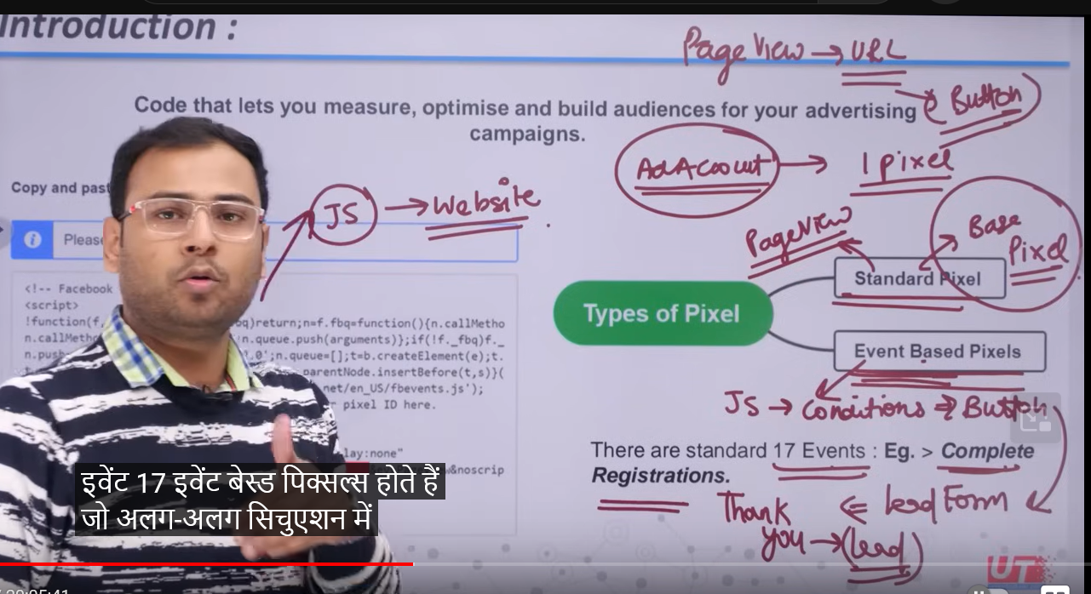

So pixel is actually a js code that you put in your website but how you put it in your website

It all depend on website technology

If we talk about some common technologies that is wordpress , woocommerce, custom made website

We have to fire the pixel code in every page because we want to track whenever some come to any page of my website its information is stored in the pixel

For wordpress and woocommerce we have plugins we also have faebook related plugins

There is a plugin which is recommended that is Header Footer code Manager or we can use google tag manager because this Facebook pixel is actually a tag

Teacher is recommending Google tag manager

So first connect it with our website

Then the further code you want to add in your website whether it is Google analytics and facebook pixel then you do so by GTM

So for cusom website we use GTM and then through this we add facebook pixel

Or you can give this code to developer and then he will add or install it in your website inside headsection (who knows) So pixeljavascript code comes insode the Head dection

Now how will it help us

Now suppose we take that code from our ad account and then integrate it in our website

It will help us to measure

Actually when your pixel get connected to your website then it will show information like below

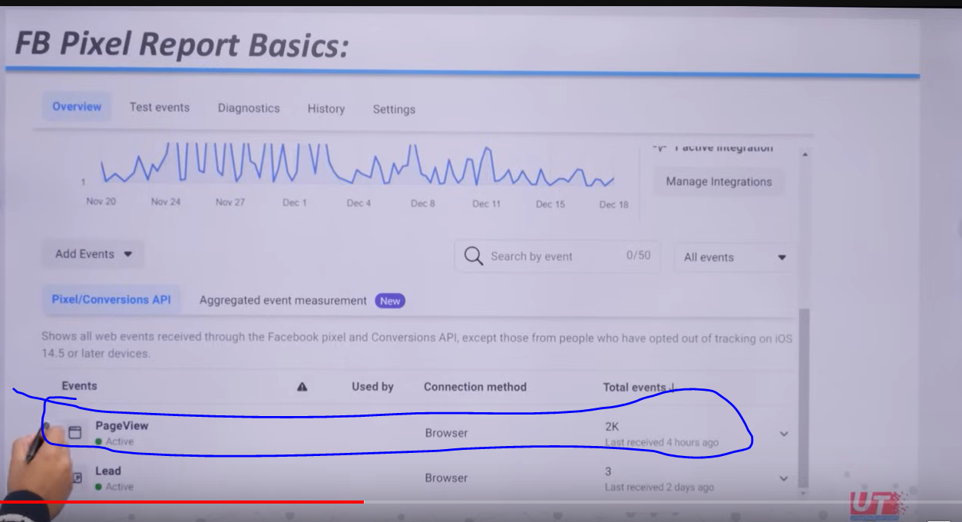

In above image you can see the information of page view because base pixel capture it.

And you can see above there is 2k view as marked above

**Phase 52**

And when we will open it then we will come to know about different page pageviews by url

No more information the the base pixel will give us.

We have also set up events which is lead as you can see above

Because we are basically actually fired event pixel and because that we can see that there is three events happened here whatever lead condition we have defined that when we consider that lead is generated

Lets say someone visit our thank you page then we will say it is lead

If there was any condition then we have defined it

So when someone reach thank you page there we can say the lead is generated and the code get executed

And its information is stored in facebook

The benefit of pixel is that if you have facebook pixel installed then ou have a control to view our data

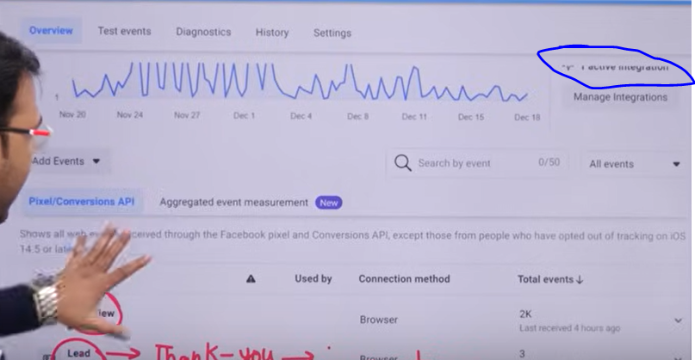

You can set the date also from marked above(Teacher says )

If we can measure it then we can optimize it by finding that what problem Is happening there

If we can measure, optimize then we can also build audience then

That’s why pixel is more important

We do build audience because so we can run our remarketing campaign properly

Suppoe we have a website and the traffic is coming from many sources

Some audience is coming because we write something in Quora

Some are coming from Youtube

Facebook organic audience

Facebook ads audience

Instagram

Articles

If we have facebook ads then we must have facebook ads account and we put its facebook poixel inside the head section of the website

Now what this pixel do

It will track people coming from various platforms

Now suppose we have 120 visitors

Now suppose among them only 2 percent people were converted

We assue only 2 or 3 people were converted then remaining 118 people were converted

By converted we can mean any activity we termed as convergence whether it is form fill

You have not done activity

So facebook pixel give us strength and it will help us to make the remaining people as an audience

Now an audience set is created

So facebook pixel is actually creating bridge due to which the people coming in our website we get there information in our facebook ads and then we can shoe ad to these type of people

That’s what remarketing is for that

It is not that here we are just convincing those people who has not converged

Facebook keep tracking lots of things Lets say I created an event of whoever has clicked on the submit button

Or we have added event of checking whoever played video in my account

If we can configure this information with right way then this goes to my Facebook ads account So Facebook pixel give us capability to make even audience on the basis of this . It is not that visitor we track there are many things we can track

In the terms of E commerce it becomes more powerful we can track those people who come to our product page and did not do add to cart and the people who did add to cart but did not checkout. You can create different type of audience

When we talk about advertising what is there instead of audience

You can start from anywhere if you start from saved audience then what is the maximum fight is about that we have to create a better audience

Then we get an option of custom audience

The pixel discussion we had done is of custom audience

As we know Custom audience is an example of warm audience. So you can understand by your self

So now you can understand how much important role does the pixel play

But there are some faults(pange)

Because IOS 14 disturbed everything

It weakened strength of pixel of making audience but it has different dilution which the teacher will talk about later when he will talk about IOS 14 later updates

The effect of IOS 14 is not thst much the ads stops running oe we will forget about facebook or not run ads on facebook . Yes things are disturbed but we will see how to deal with these updates

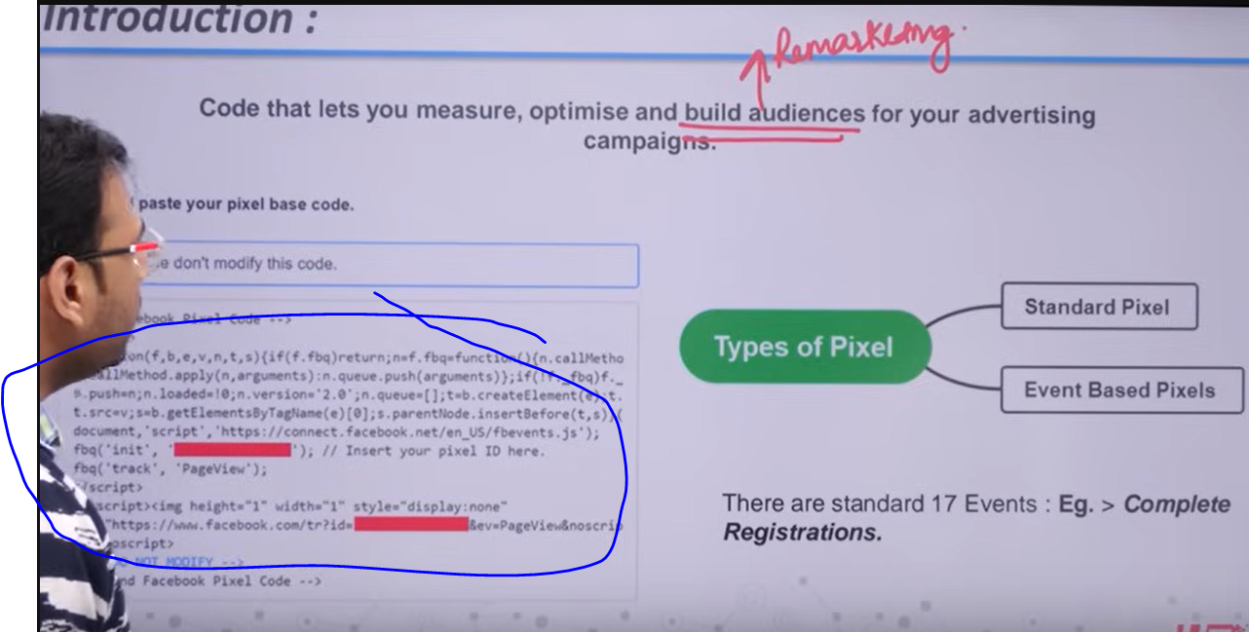

The above marked code is a base code without it

Without base code our event based code will not work You will fire base code in all the page which means whenever a visitor comes then the base code get triggered

If someone ask you where does the pixel help us

The first point is remarketing and then it help in measurement and optimisation

It will tell you about data day wise

The source of traffic can be from anywhere the pixel tracks it.

**Phase 53**

Whatever the visitor do we can make audience as the pixel tracks them. This is the strength of digital marketing

And this concept exist everywhere

How we will install it

AS we have discussed we will se GTM to install facebook pixel Teacher is recommending this because it is Technology independent

Irrespective of technology we have to first connect GTM with your website When it does connected then you have scope in GTM So it does not depend on technology you can use it to implement base pixel or event pixel.

Teacher will again go in technicality

The base pixel we see what does it mean Like the teacher told us previously that it I a Javascript code

You should know it if you are giving interviews as coder.

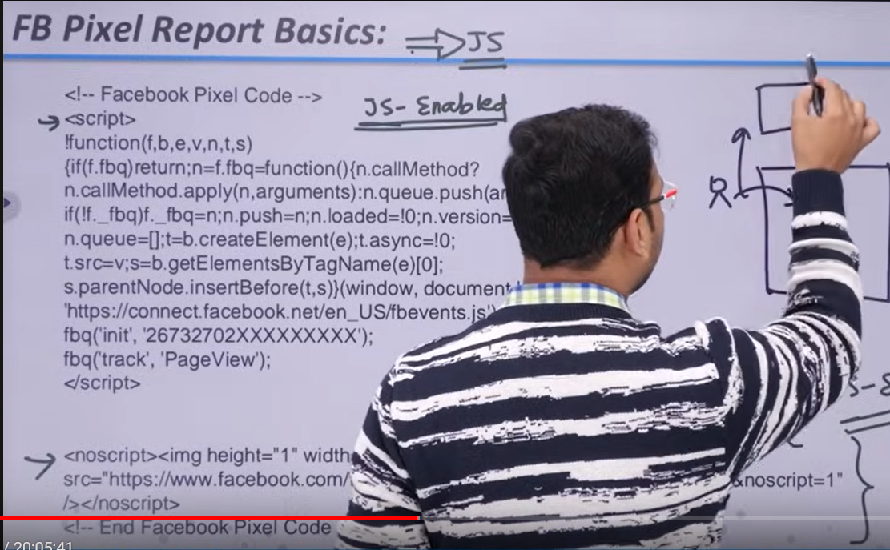

The script code part is for the browser Javascript enabled and the noscript part is non Javascript enabled(the browser who do not support Javascript) but nowadays javascript is found in every browser because nowadays javascript is mostly used to make website

You can also see in script part that in function there is parameters f,b,e,v,n,t,s these parameters

These basically call the events libraries inside the function (calling libraries at runtime maybe)

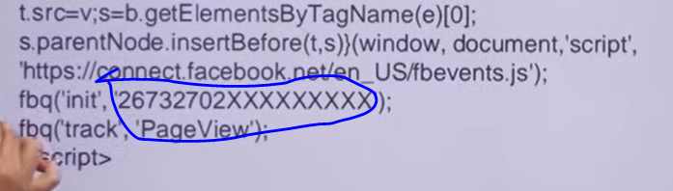

The above marked area basically initialize the pixel by a code maybe

And now the fbq (‘track’,’PageView’)

Is saying we are tracking our page view which is basically Base pixel

It is not tracking registration and you can see the details in your facebook as shown below

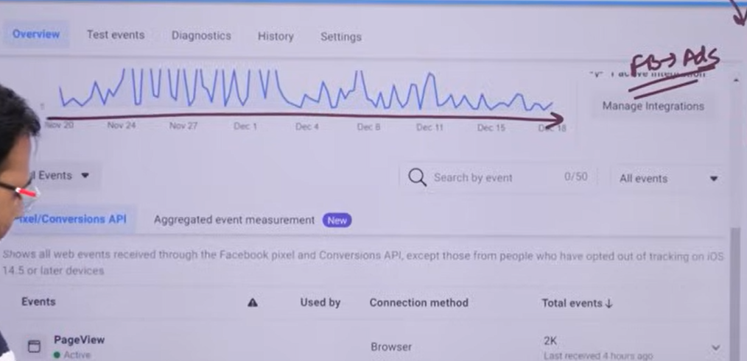

The remarketing audience you are going to create depends on the nature of your business

Lesson 39:-

In this lesson we will learn about **How to connect Facebook pixel to Website**

We have different ways to integrate pixel in our website

And these ways depend on the technology you did use

But the way we are going to use actually is GTM that is actually google tag manager

The process is like is first we are going to make an account in GTM

It is basically used when we want to fire different pixel on the basis of different condition

After making GTM account we are going to connect the GTM to our website

Once the GTM is connected to the website then

We add Facebook pixel through GTM in our website

We can even directly add Facebook pixel to our website if our website has Wordpress then there is lots of plugin come in which we can use but why thew teacher chose GTM

If we make the habit of using GTM means we are going to add any Javascript code through GTM then GTM is a way that can be implement for any kind of technology of webite

If you have added GTM in your website then you don’t have to further think about plugin or any other things because any number of code can be fired by GTM

So GTM is a way which can run on any website if we talk about plugins then they will always work in Wordpress

Byt when custom made website come into picture then you get confusion how to work

If you see teachers other playlist where he have told about google ads and google analytics

There he tell that if he have added google analytics or google ads or remarketing code(who knows) then we do all these through GTM So it is not like we will use GTM only in terms of facebook pixel

SO a website should have GTM

So Teacher is going to start from scratch about how you are going to create account in GTM and then how you are going to take pixel from your ads account and fire it through GTM

In Googlesearch Google tag manager

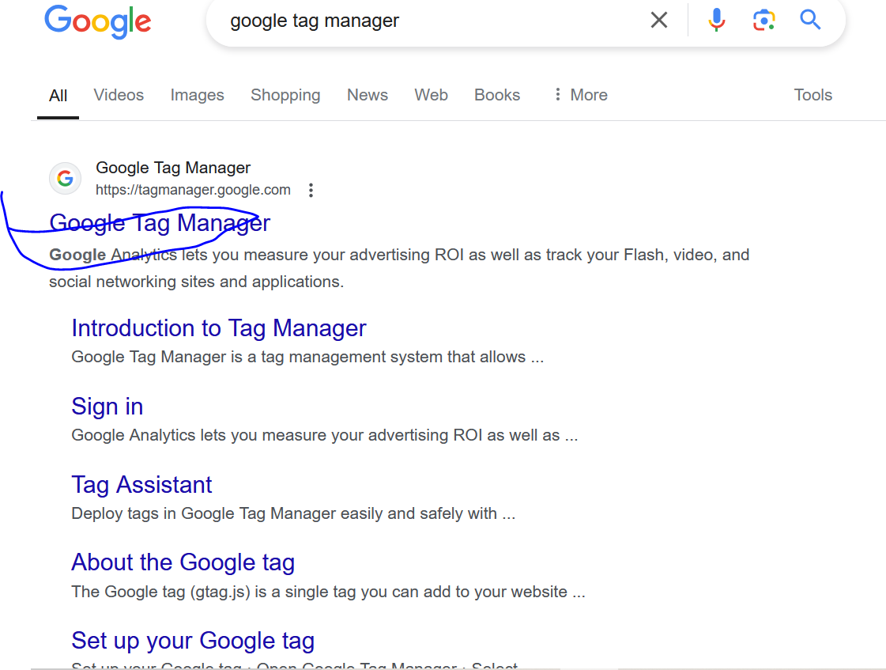

Click on the first link as above

Then the below user interface is shown

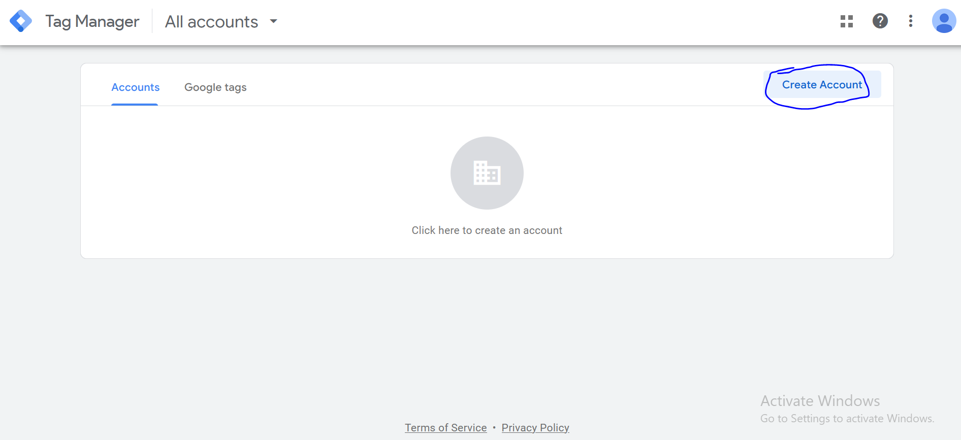

Click on create button as marked above to create an account. Now you will see UI like below

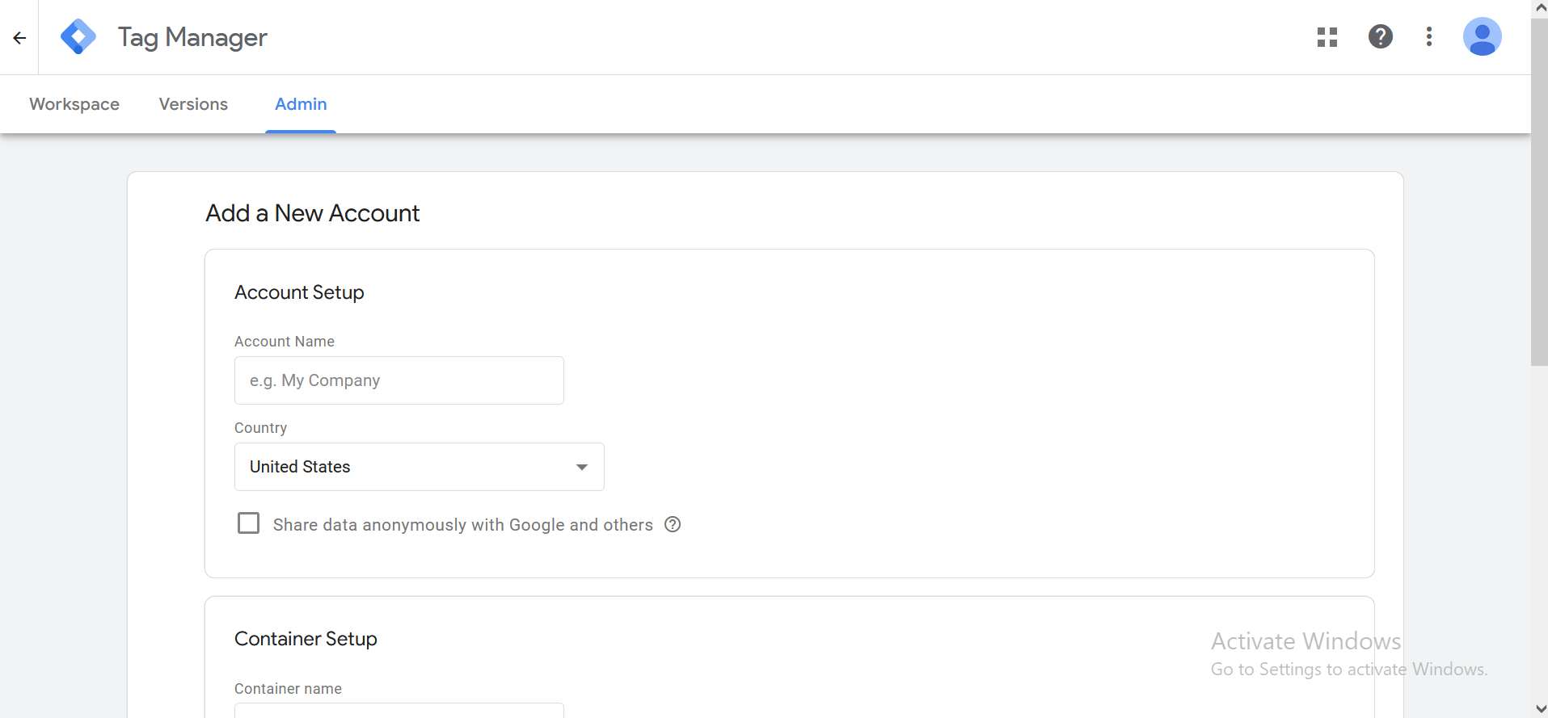

Now in account name field type the Account name

And then tell the country

And then check the check box below Country

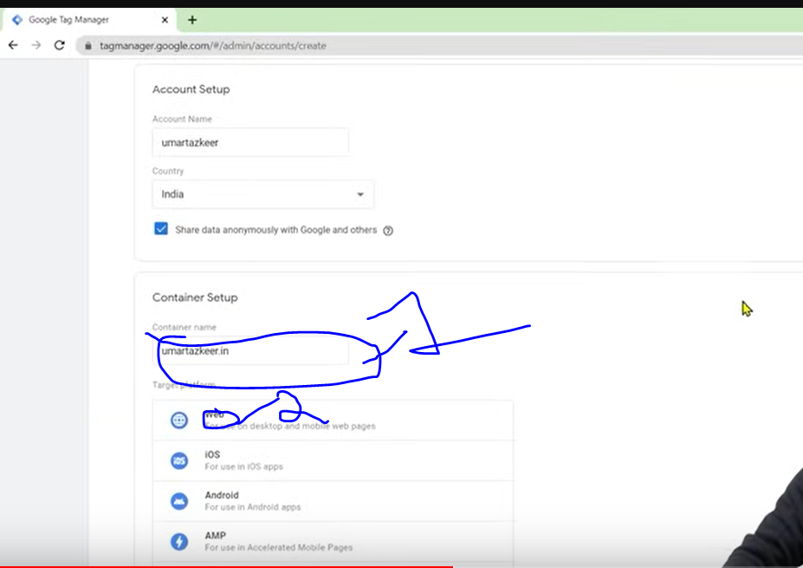

Now go to marked 1 and then tell the container name that id actually website url

Now go to marked 2 to select the web to tell that website is our targeted platform

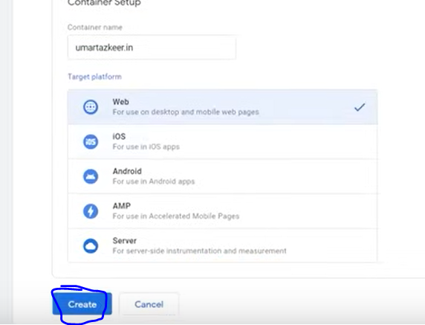

And then click on create button as marked above

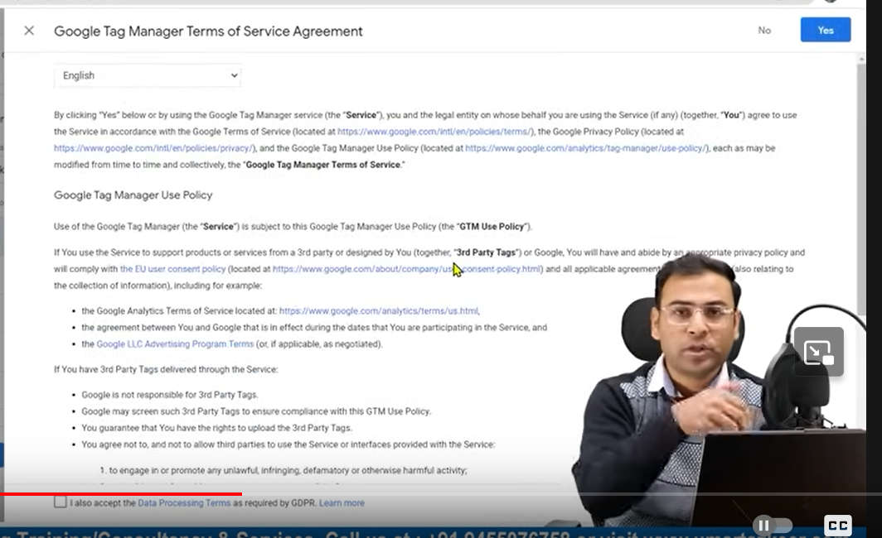

Now check the checkbox of Terms and agreement

So what process are going to do is creating an account and then connecting website to the GTM

Now click on yes button present on the top right corner of the page

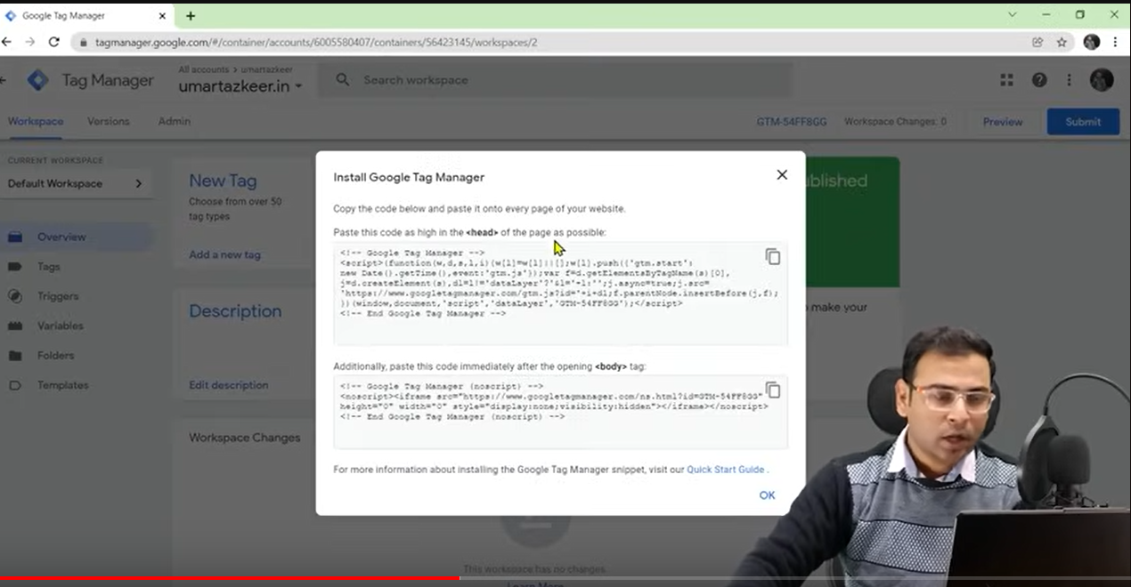

Now you see interface like above so it is basically giving you two codes to connect GTM to the website

Now as the instruction say you have to put these codes in head section and body

If you have developer and custo website or custom website then give this code to the developer then h will put these thing in your website then for further code you don’t have to touch the developer

Through GTM you can provide further codes

So to connect the website and GTM we need to paste the code in our website backend Teacher is in wordpress backend

**Phase 54**

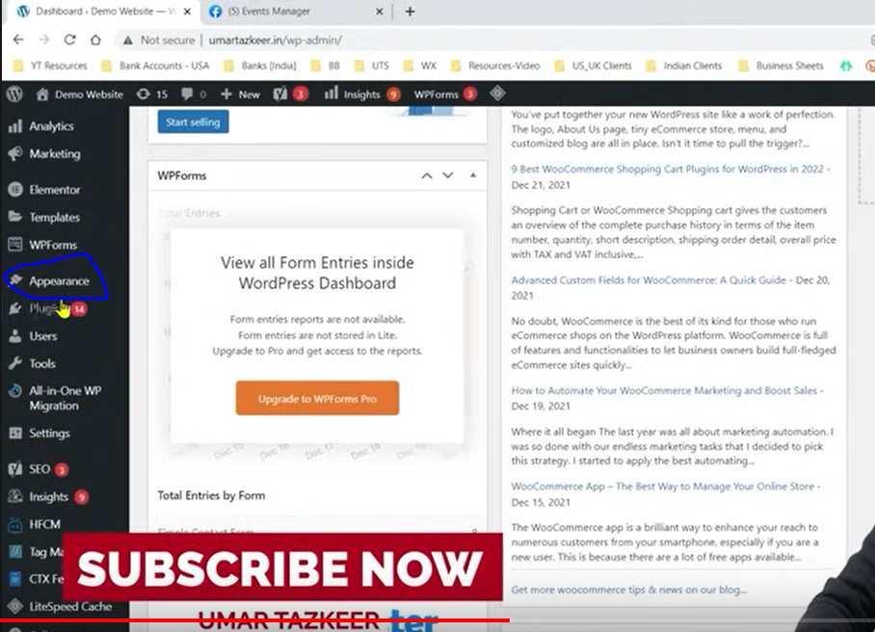

In side menu go to Appearance as marked above

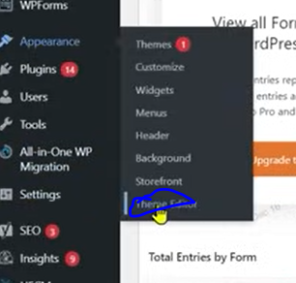

Now in submenu go to Theme Editor.

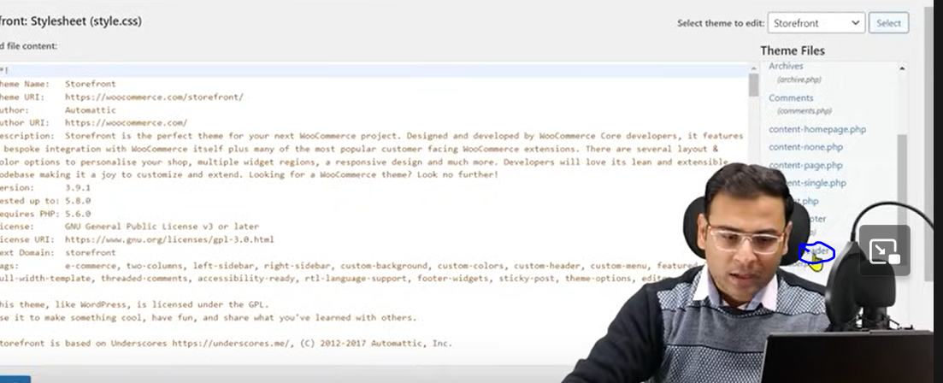

Now go to marked area as header section(header.php) of our backend

And there you need to identify the head section and copy the head related code there

And then find the body section and then paste the body related code there

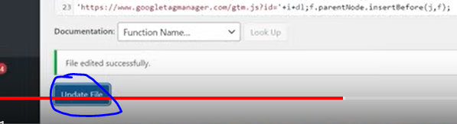

And then click on the update file as marked above

Then we have to check that these codes are present in our website or not

Now go back to GTM website

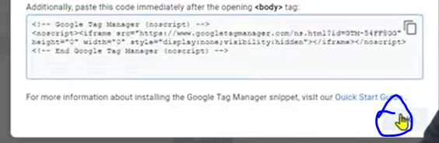

And then click on OK as marked above

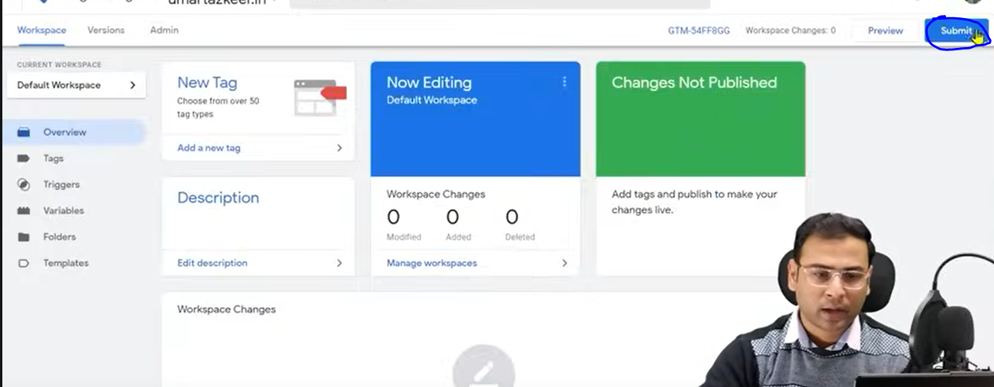

Click on submit button as marked above

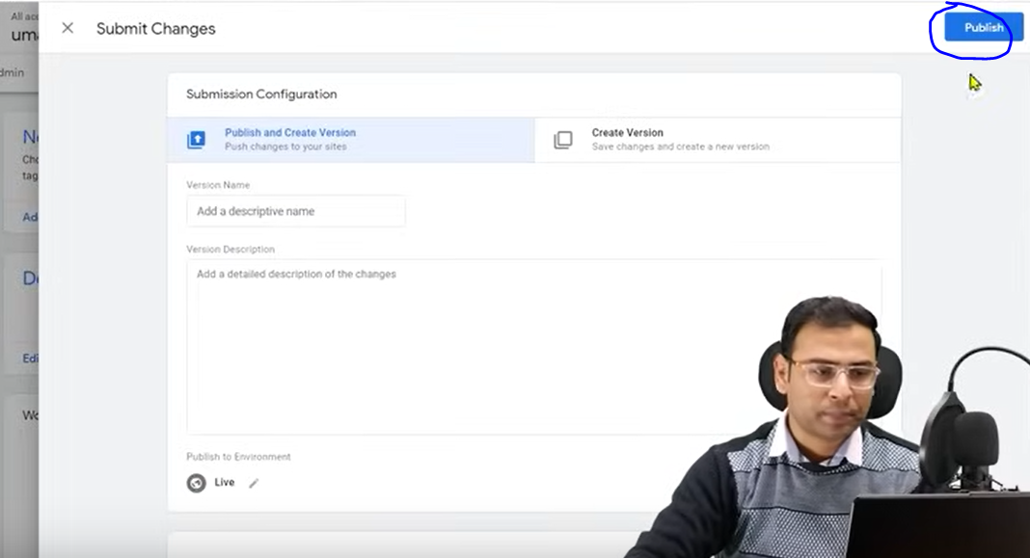

And then go to publish button as marked above

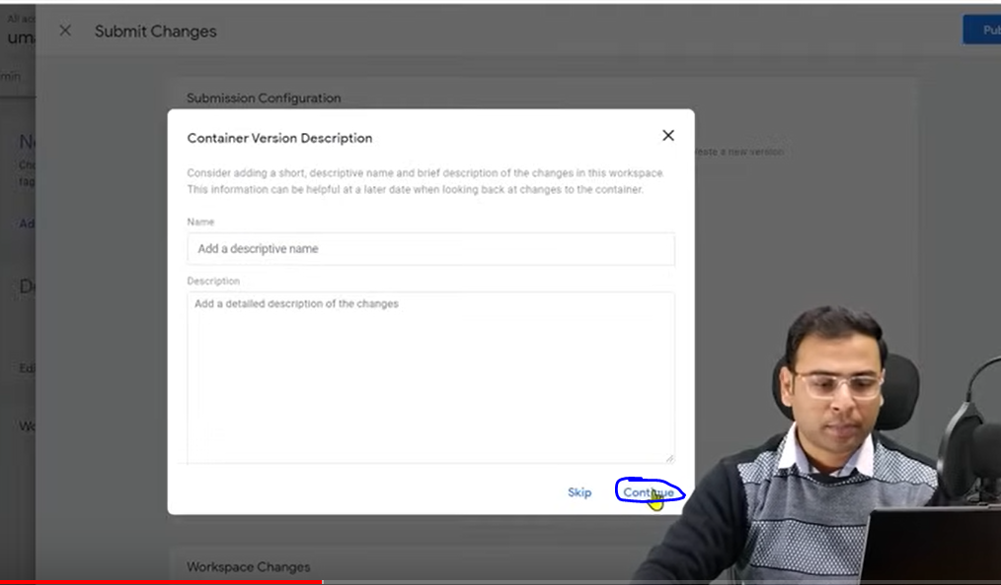and then click on Continue button

Thrn you will see the loading like below

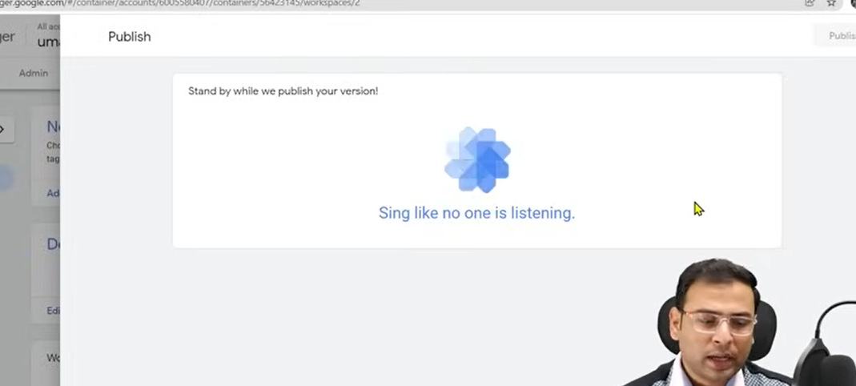

And then we check whether these code are kept in website or not

To check that there are multiple methods One way is to check is add an extenstion to google chrome that is Google tag assistant legacy and then come to your website in google chrome

And then come to your website in chrome

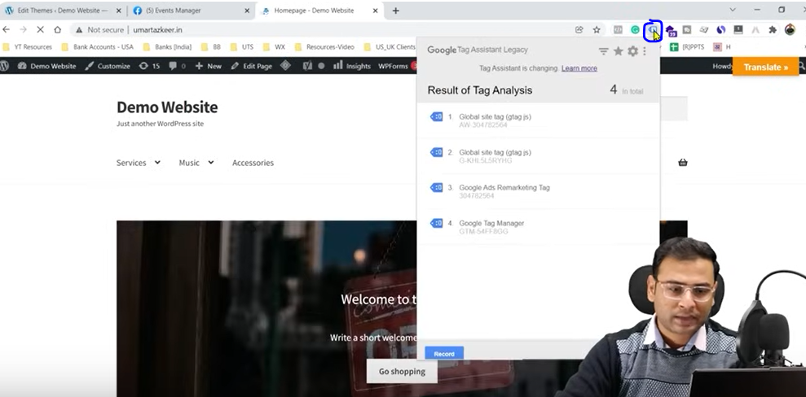

And then click on marked area above to show a submenu telling all the google tags insode your website

You can see the name google tag manager is listed in the submenu of result of tag analysis

Below this you can see the unique goggle tag manager id

Now we will check that whether the tag manager in website is same as the tag manager we added

Now in GTM website go to workspace tab

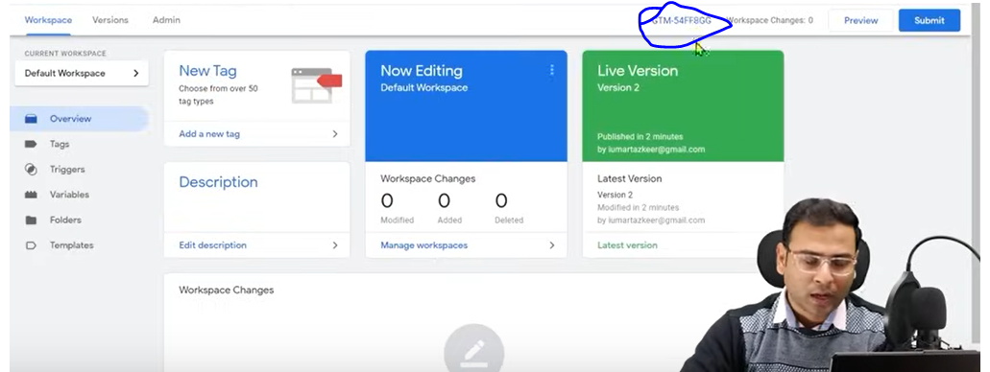And then you can see the number from marked above and match it with the extention

Now we want to add a facebook pixel in pur website for that we will go to facebook ads

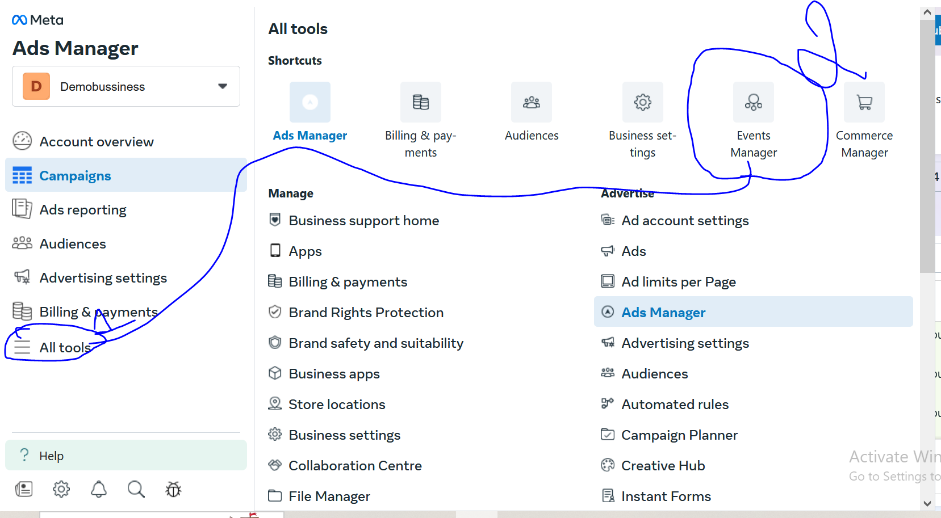

Now go to marked 1 All tools and then go to Events Manager

Now the event manager will be opened

And now in event manager side menu

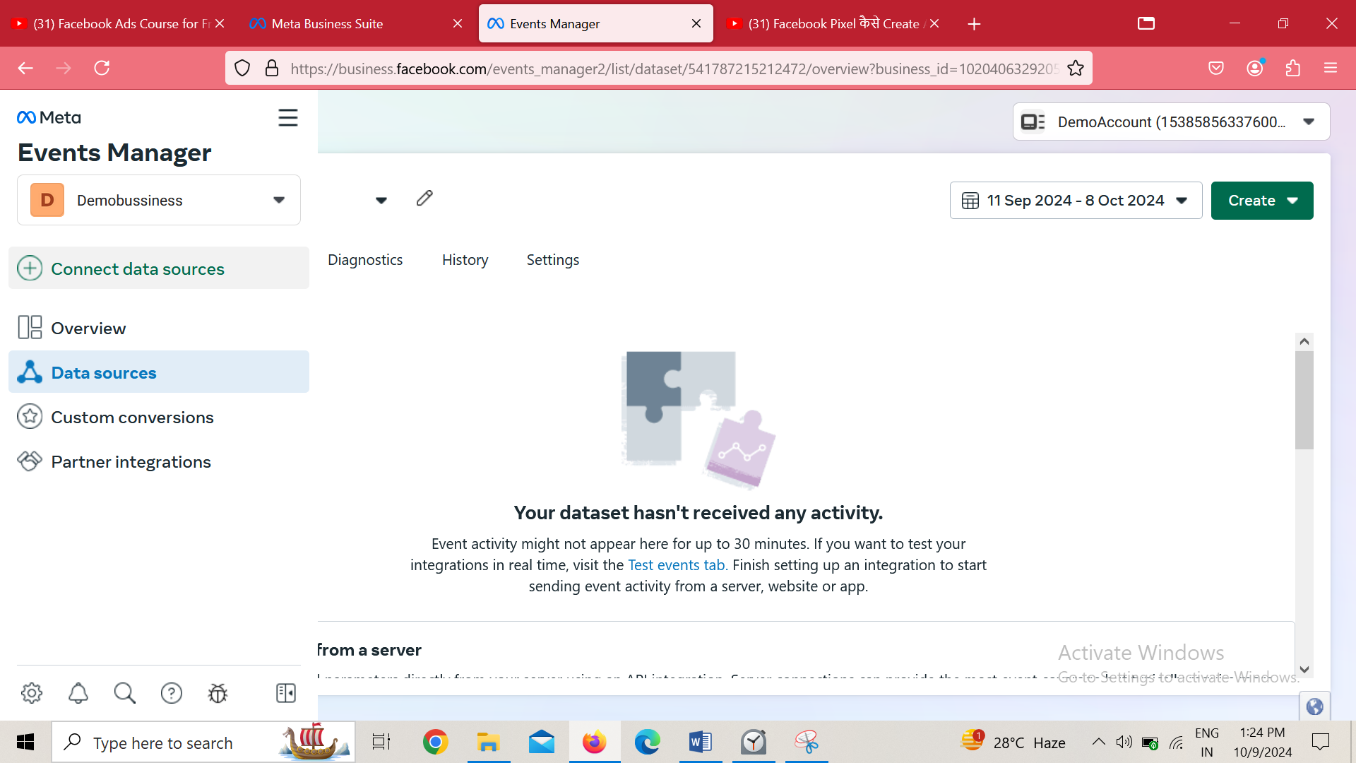

Go to Connect data sources

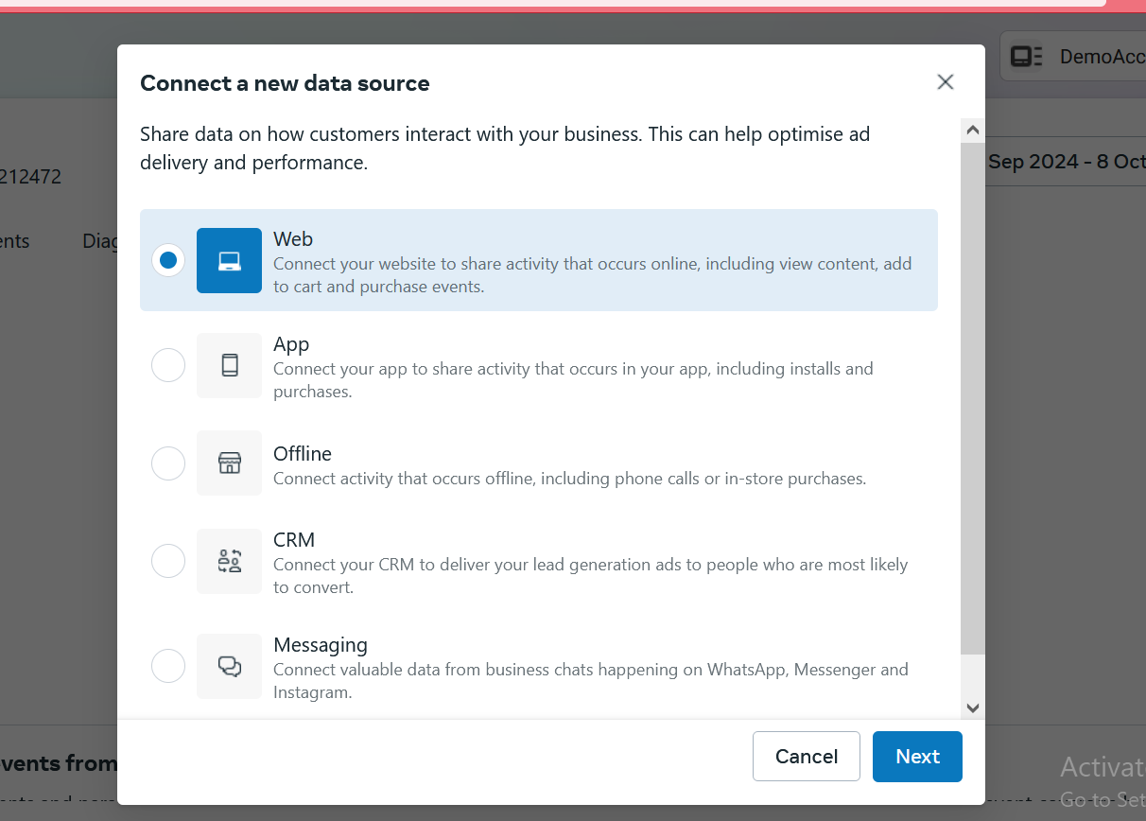

Now chose web and then click on next button

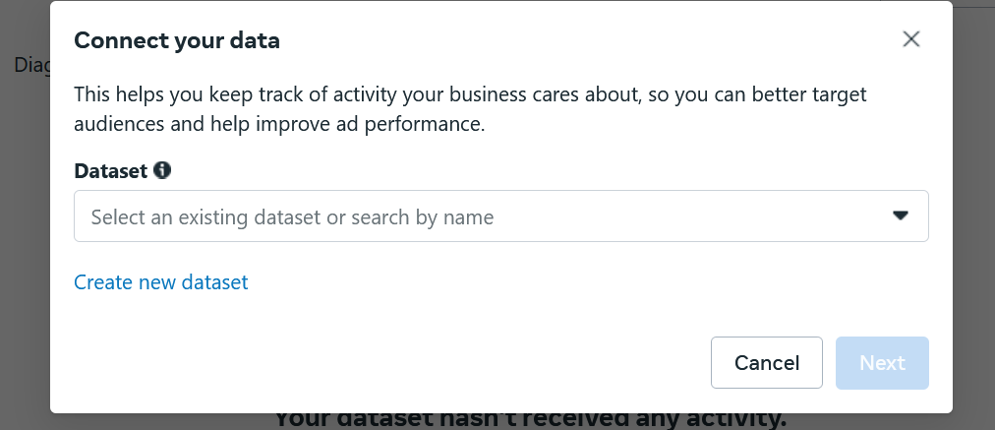

Now click on create new dataset Now your mini window look like below

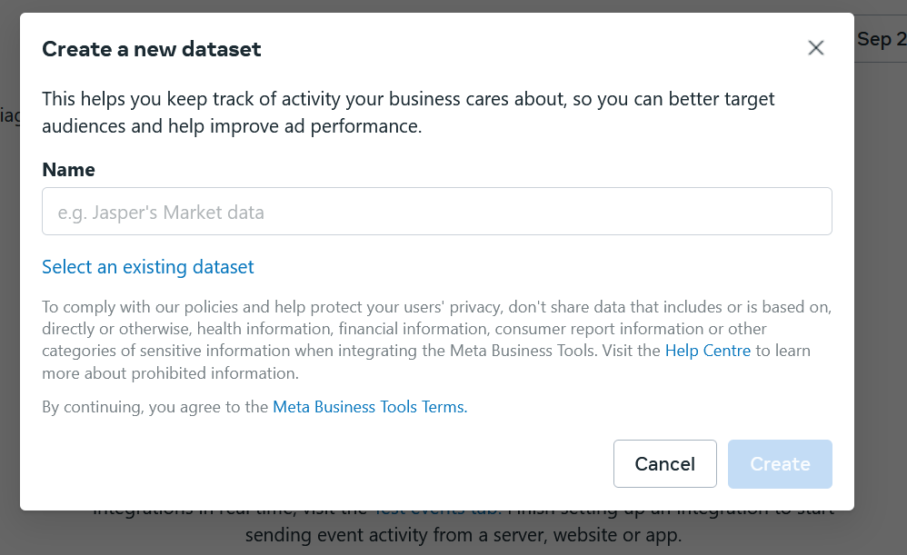

Enter the data source name in the above field and then click on create button

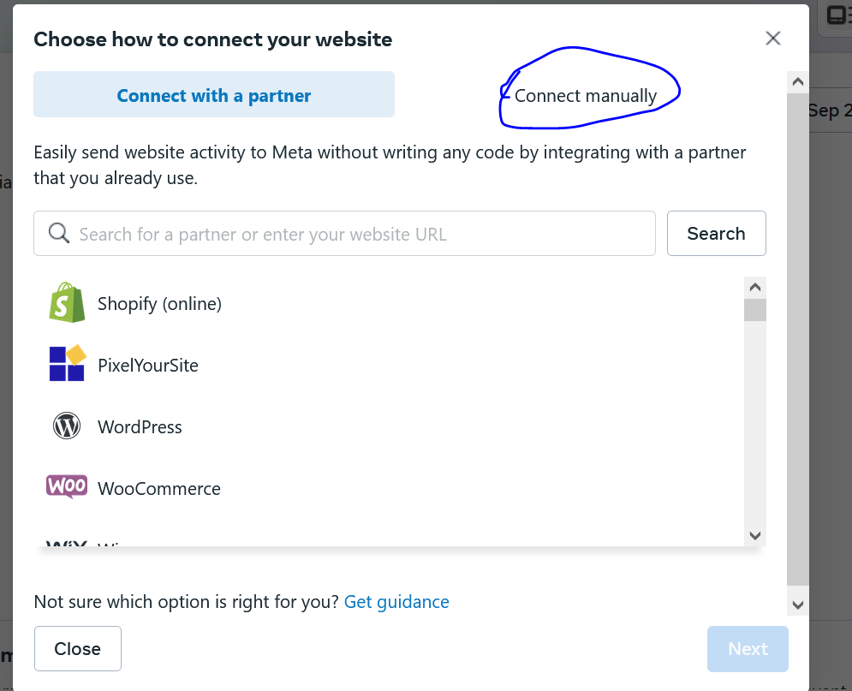

Go to connect manually

Because we get sometimes defect after choosing partner

They basically provide yiur some ease by telling your website is in what platform and then you can connect your website to the pixel but the teacher recommend manual

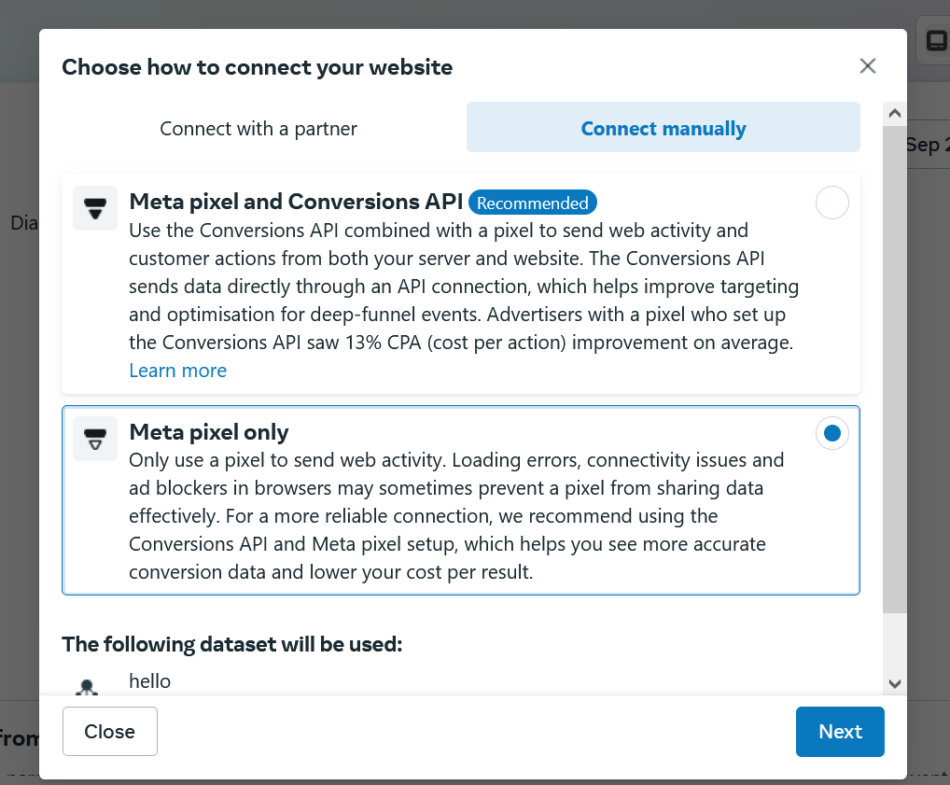

So after clicking on connecting manual go to Meta pixel only

And then click on next button

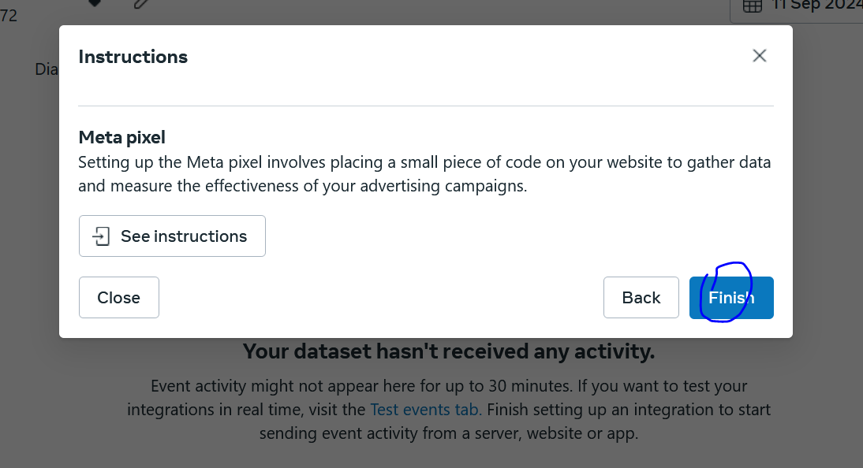

Click on finish button

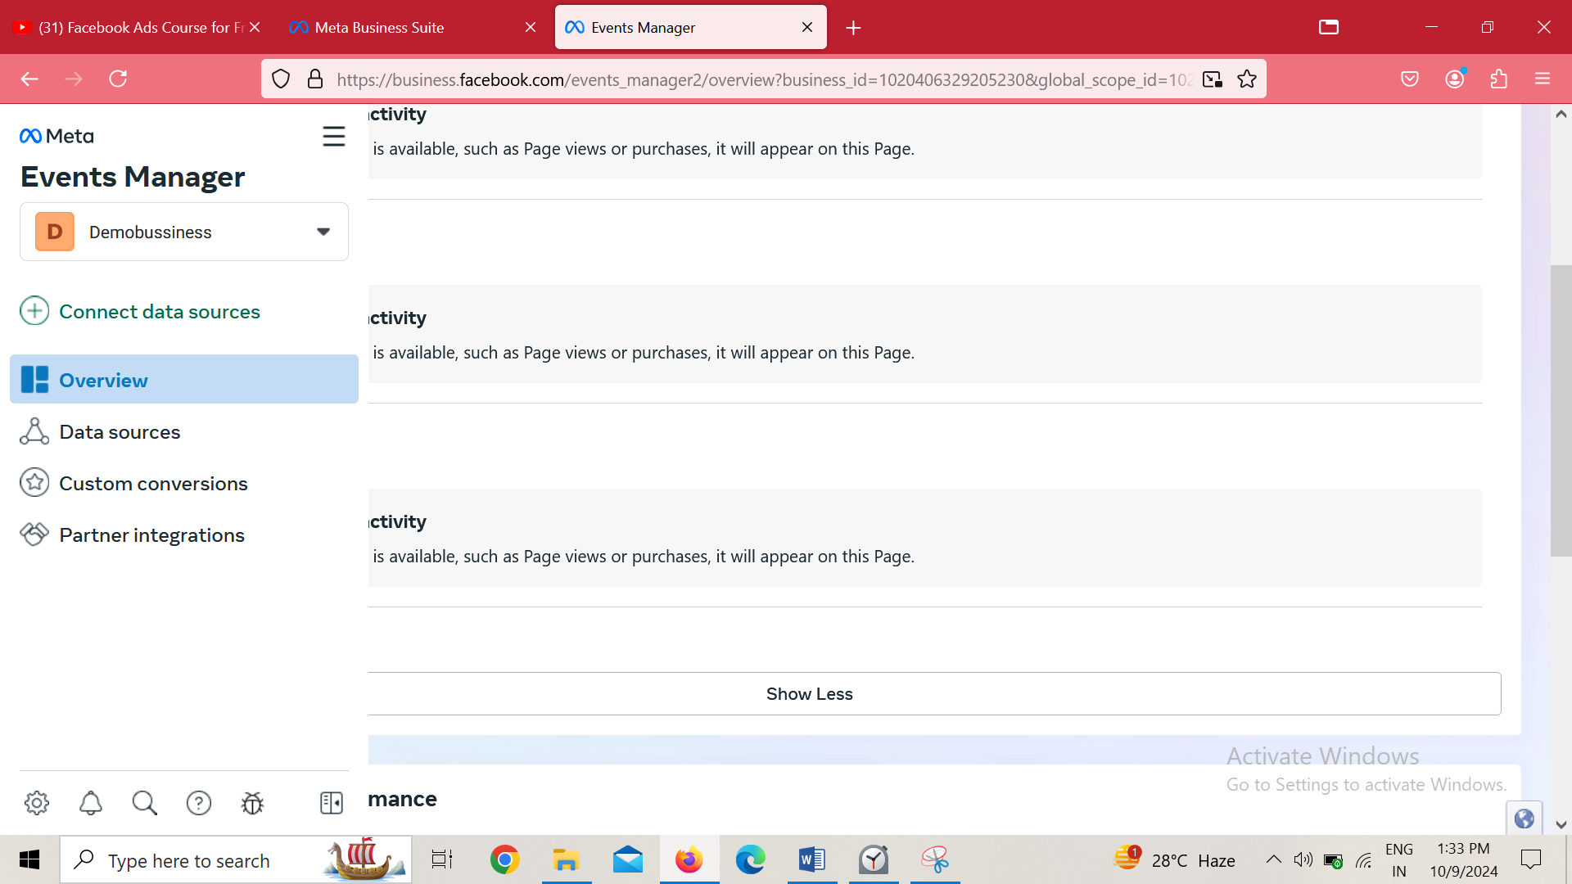

And now go to Overview sidemenu

You will be shown a list of data sources

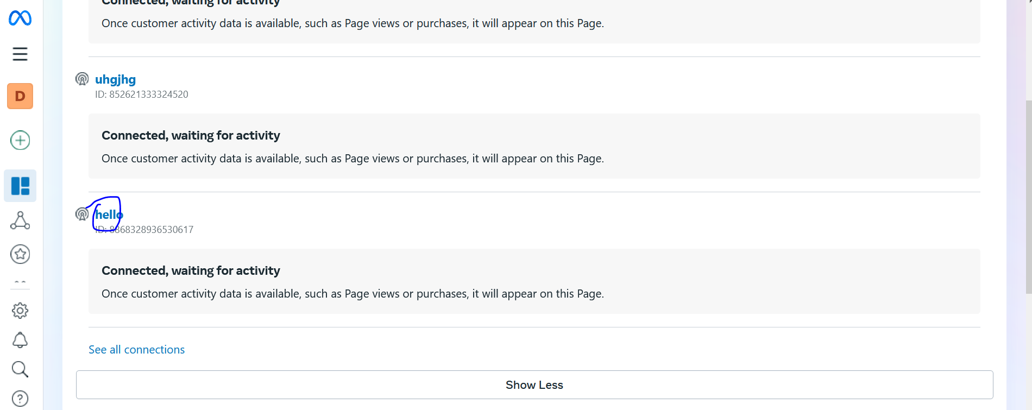

Now click on that data source we created

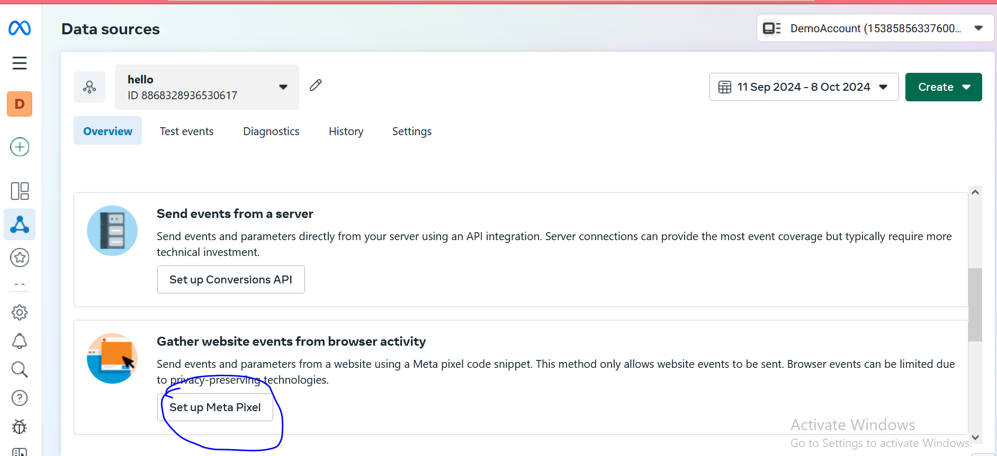

Now click on set up Meta Pixel button

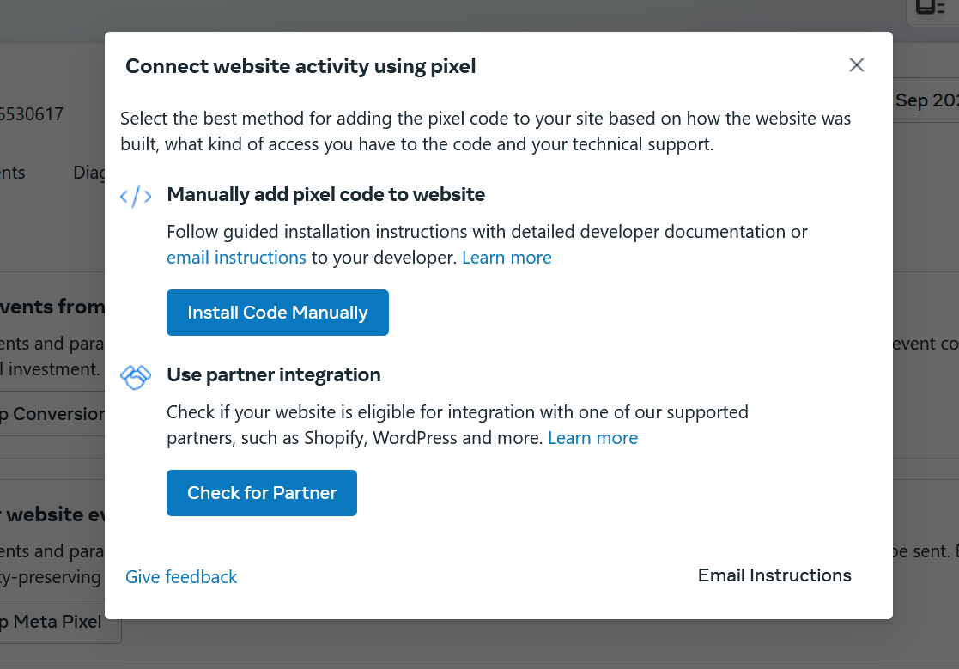Now a new mini window will be shown lie above

Now click on Install Code Manually

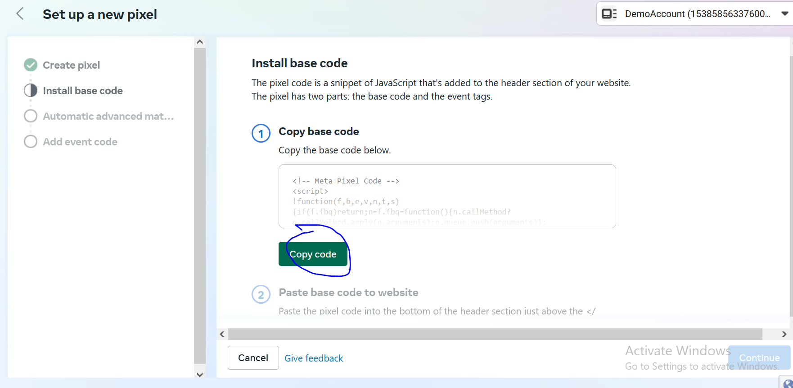

Now in new window like above click on Copy code button

Now we will go to GTM website again

And now in sidemenu go to

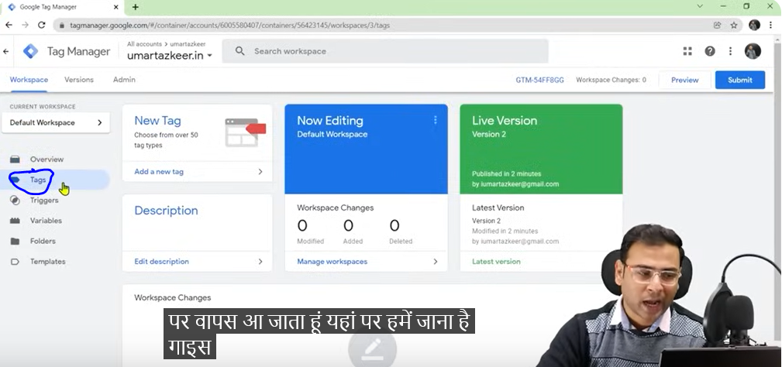

Tag sidemenu

Because we want to create a new tag

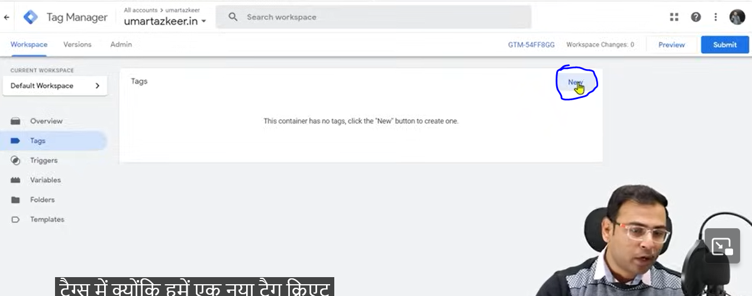

Click on new button as marked above in new page opened

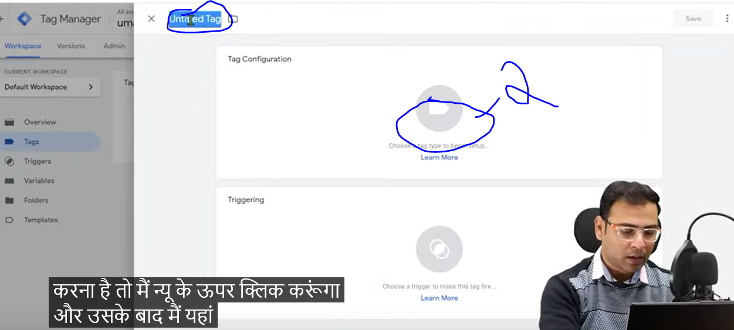

Now tell the name of the tag as marked above in the side section and then by clicking on above marked 2 choose tag type

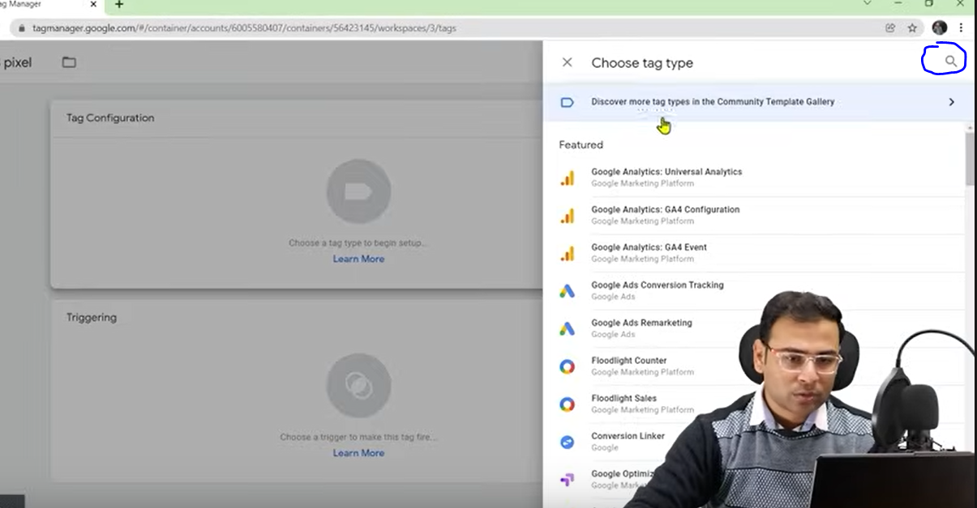

And then in search marked button to search about type of tag

So search HTML

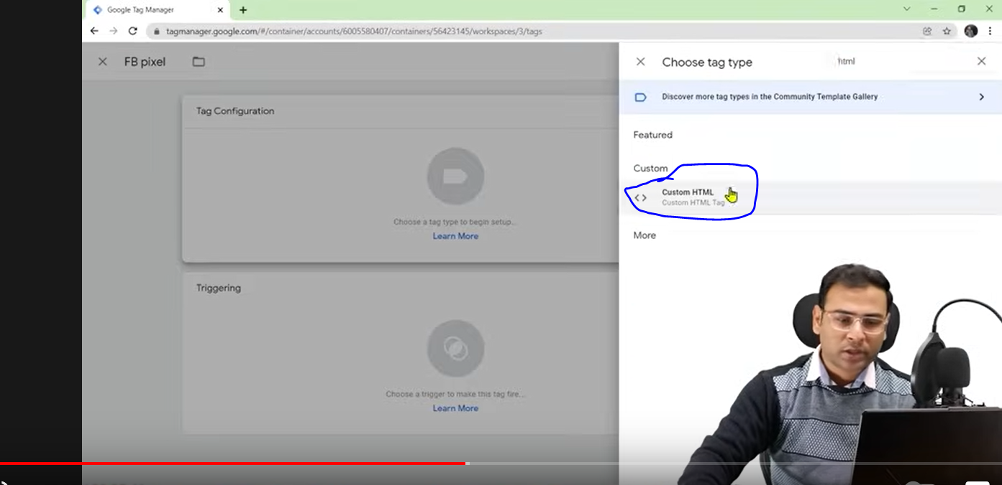

And then in suggestion list click on custom HTML as marked above

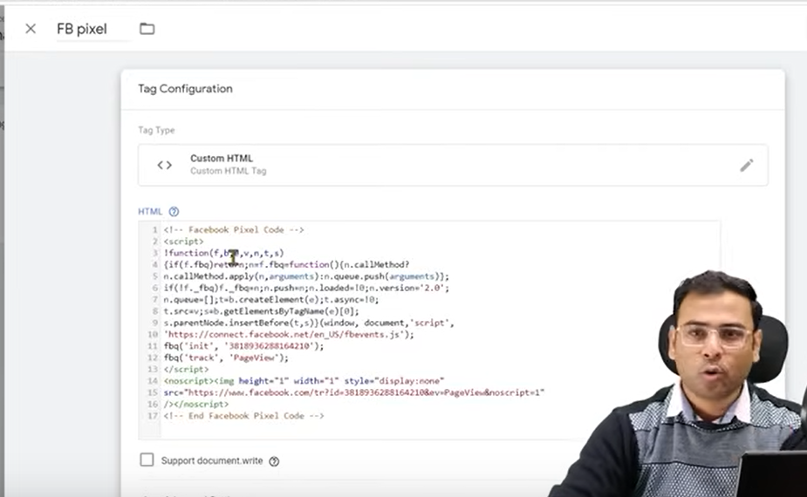

And then paste the code in the field of new mini panel opened in the center

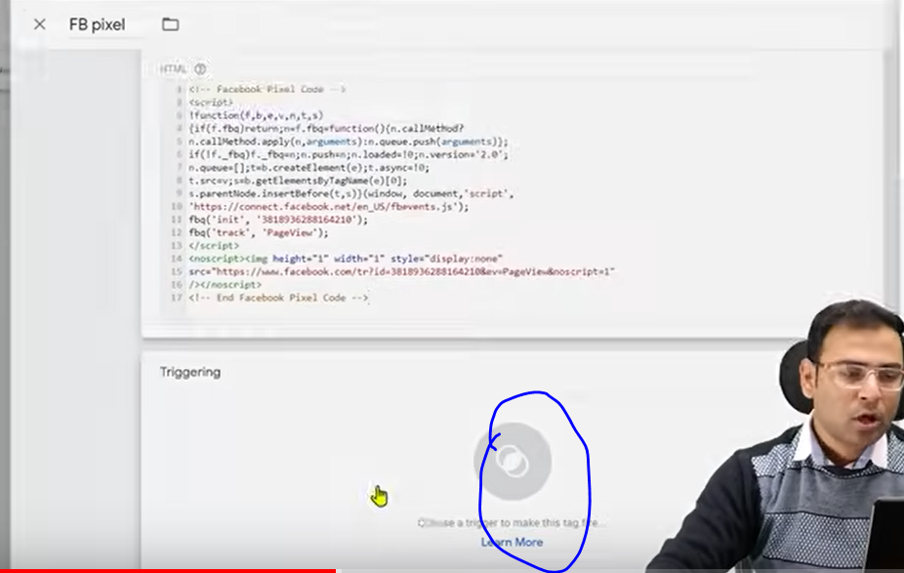

And now click on Triggering box as marked above

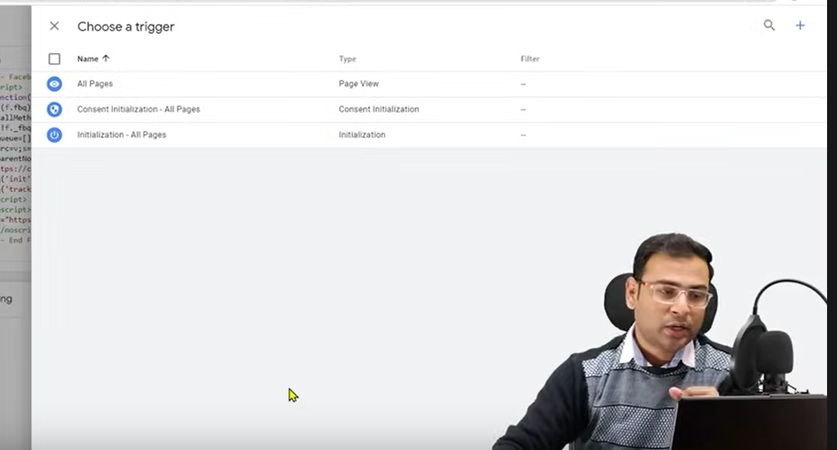

Now we want that pixel to be present on all the pages so click on all pages

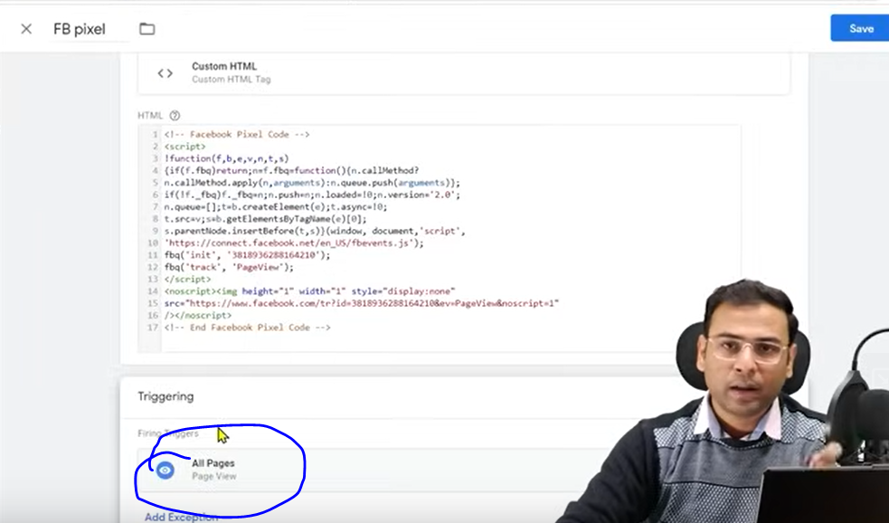Now you can see All pages mentioned in Traggering

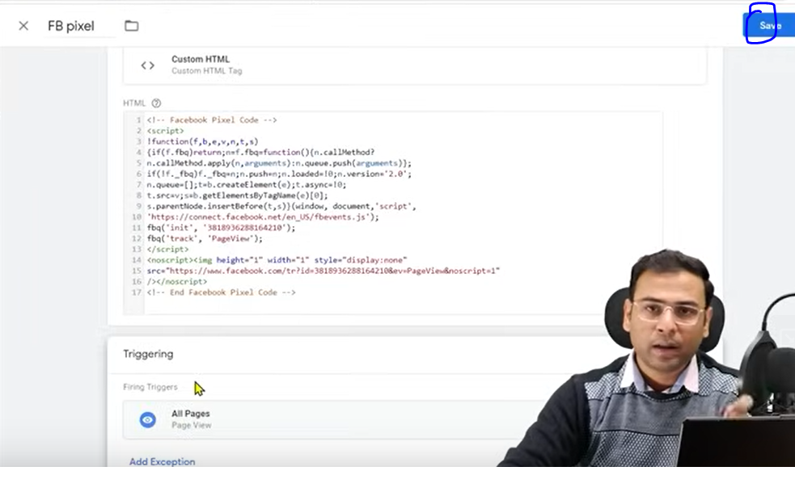

Now click on save as marked above

But this tag is not live in our website

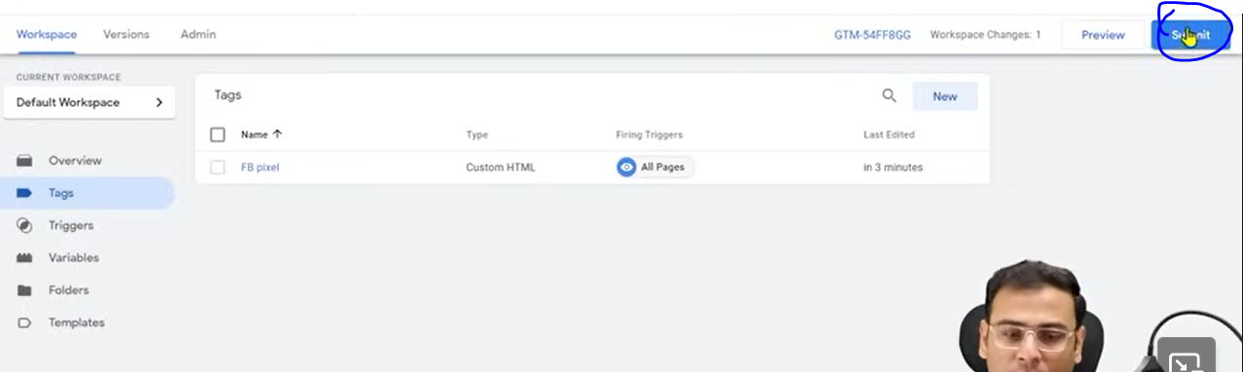

And then in tags submenu page click on submit as marked above

And now side menu will be shown

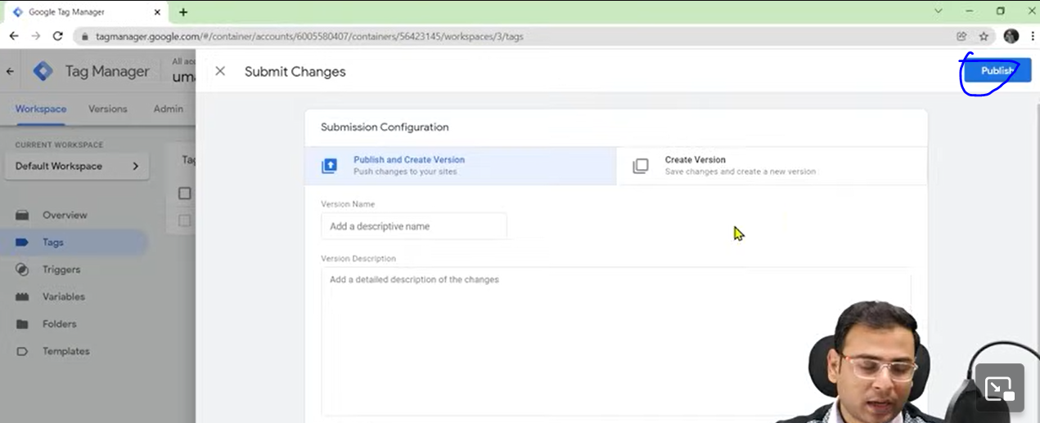

Click on publish as marked above

And then a mini window will be shown in the center

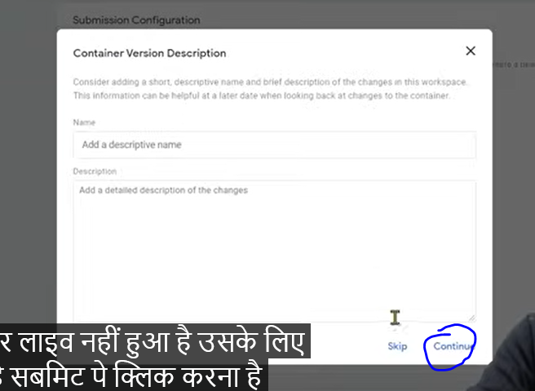

Click on continue as marked above

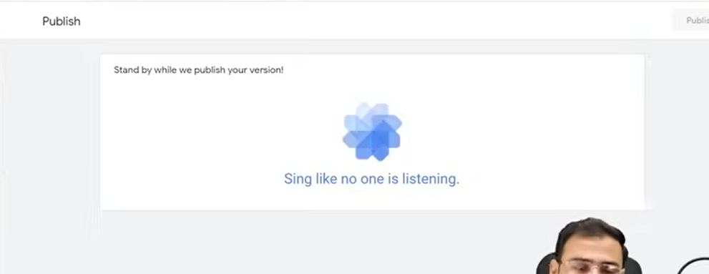

Now you can see it is being published

Now our tag is live

Now we have to check that whether we have installed the pixel in our website properly or not

So for that we have another extenstion to be used

that is Facebook pixel helper

So if in any website there is Facebook pixel code it will able to identify it

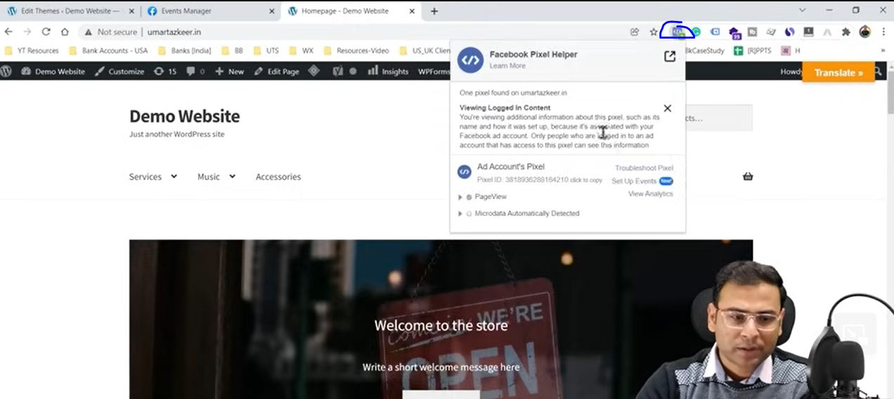

Now by clicking on marked button to see the facebook helper tooltip to know if there is pixel helper or not

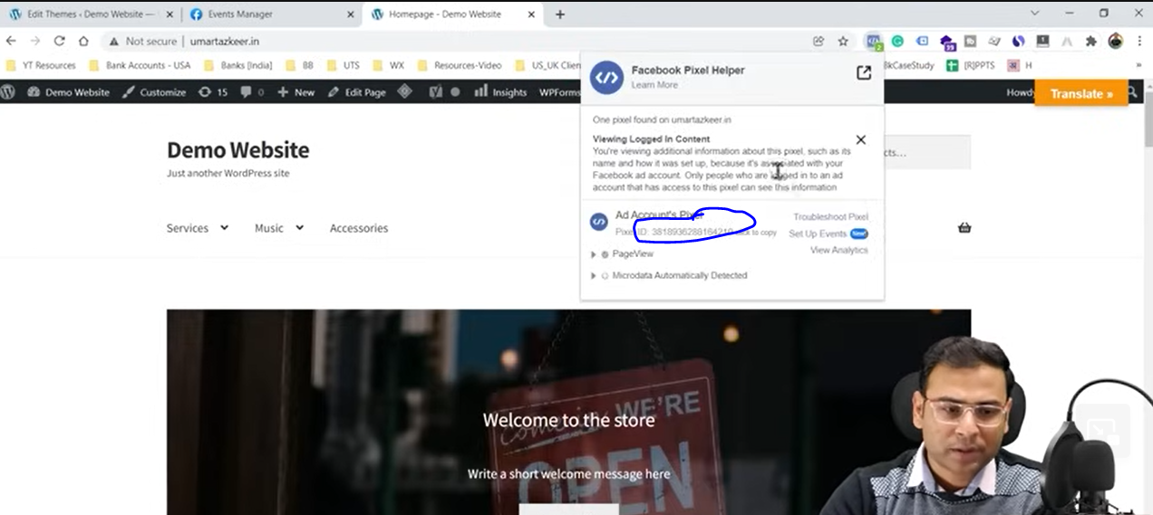

Now see the pixel id as marked above and then match it with shown in facebook event manager

Now we will see the code in event Manager

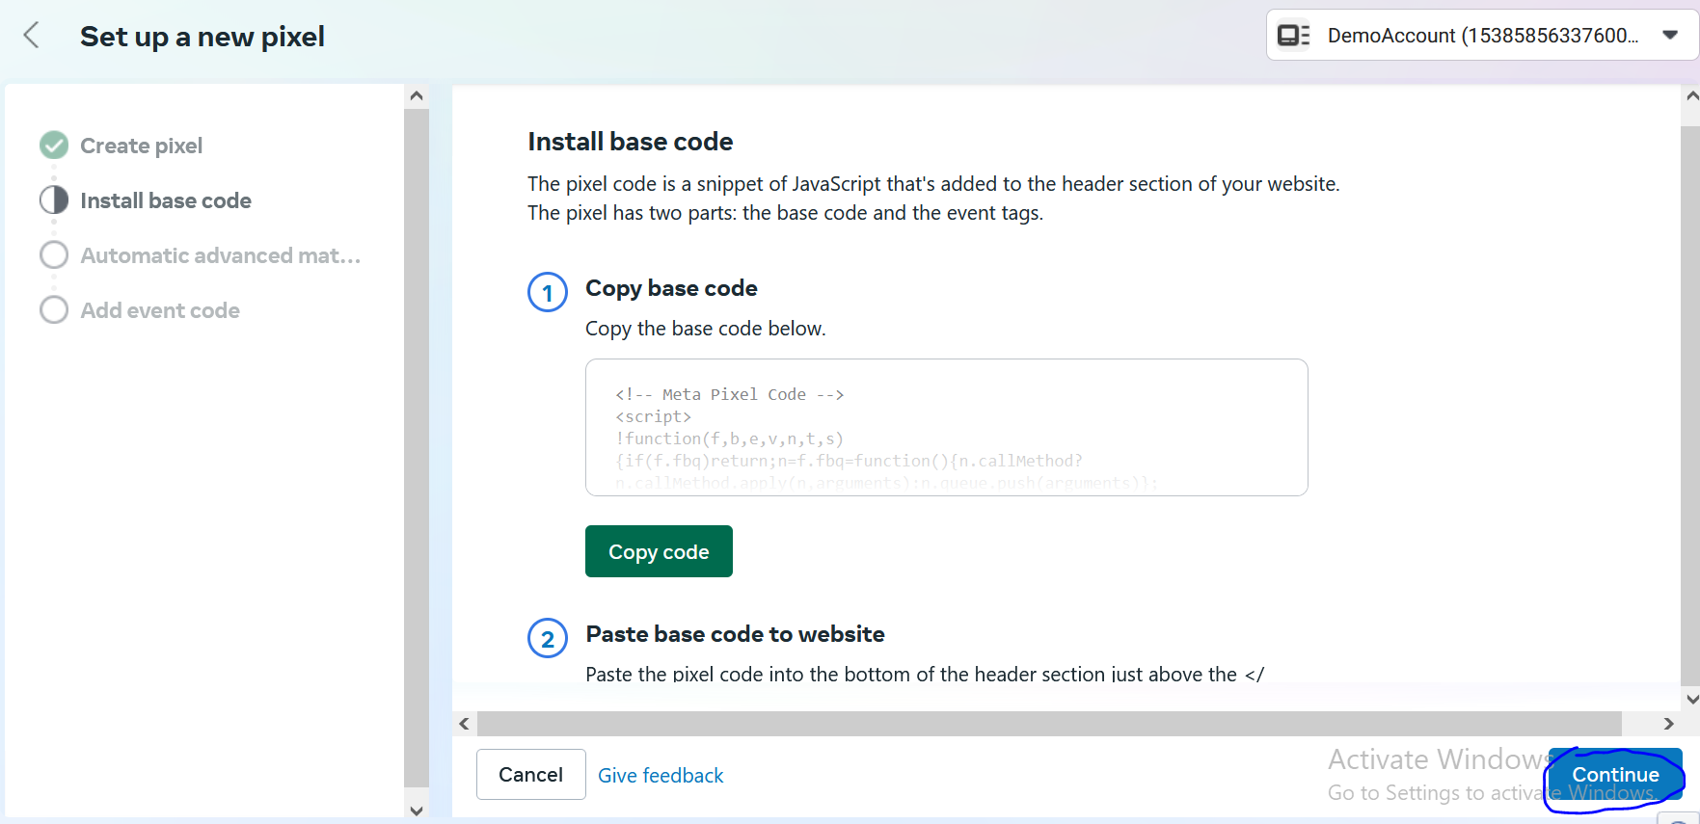

Now click on Continue

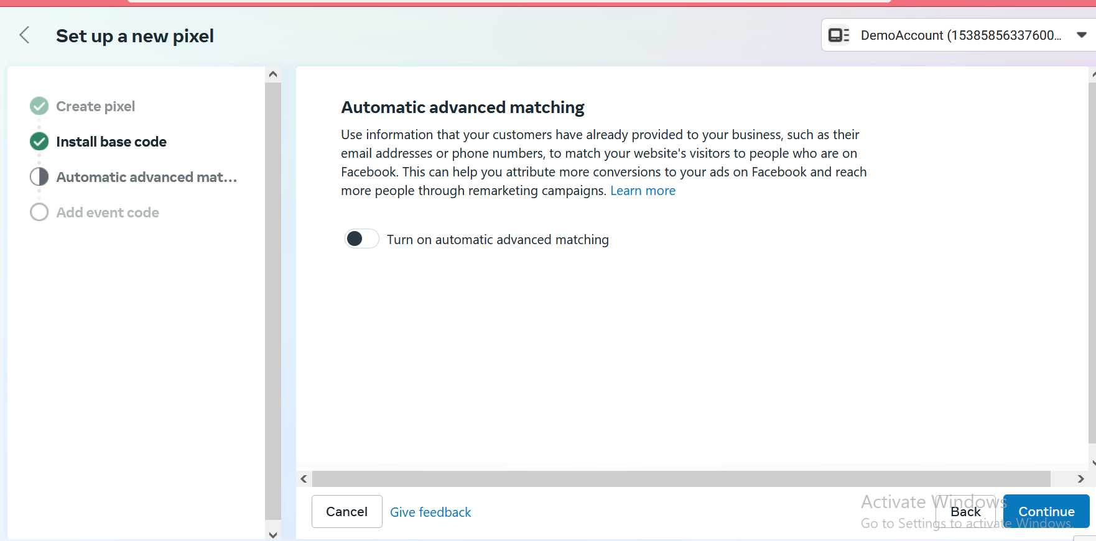

And then again continue

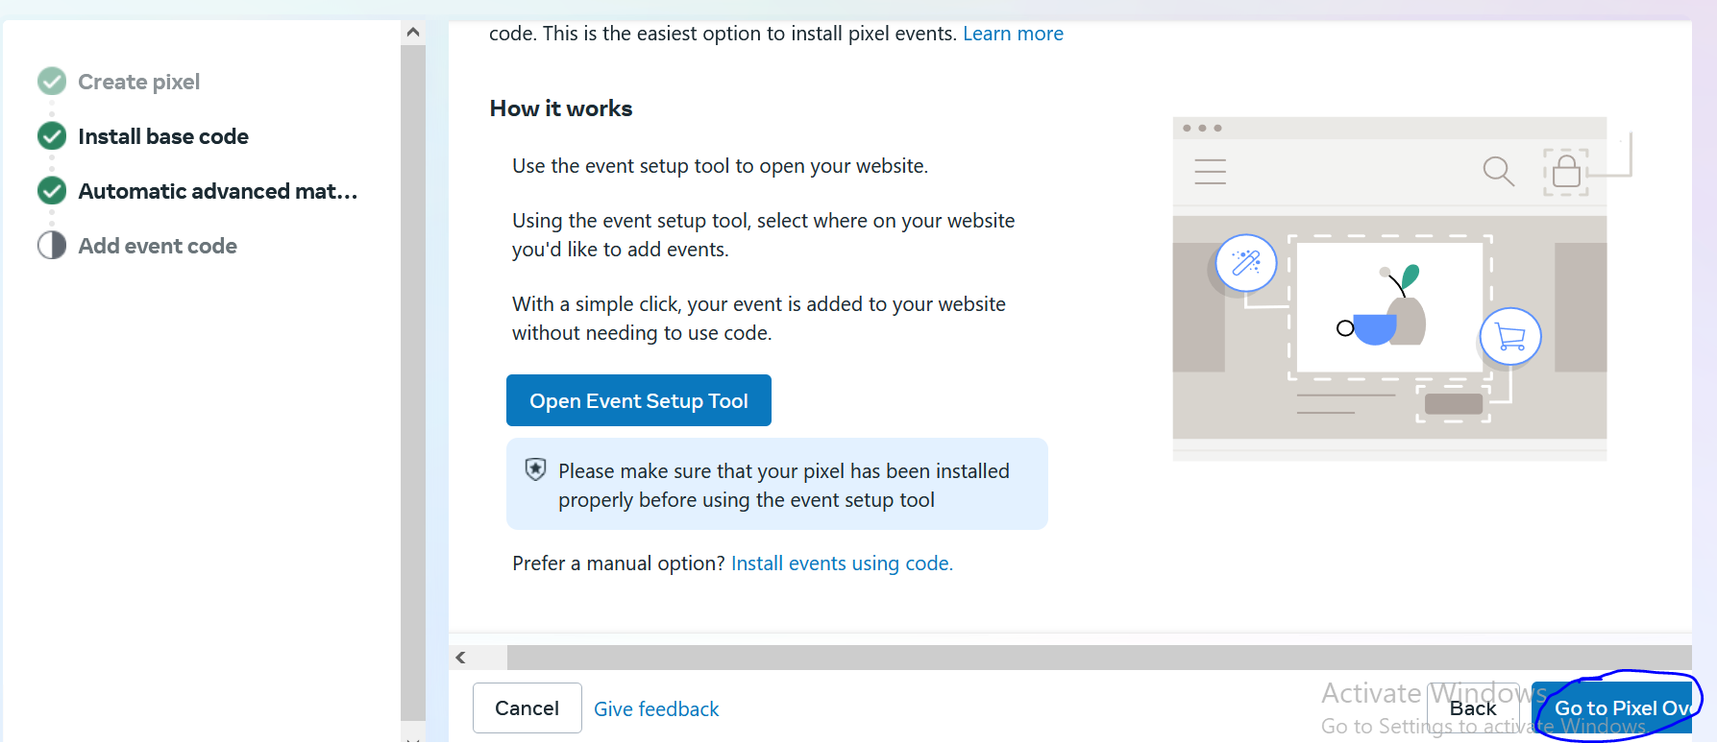

Now click on Go to Pixel Overview

As marked above Now again check your pixel code (from above)and then match the code inside it by pasting it in a text editor to the code shown in extenstion

By using GTM it will be benefetial for you in longer run.

It will be great irrespective of the technology used to make the website

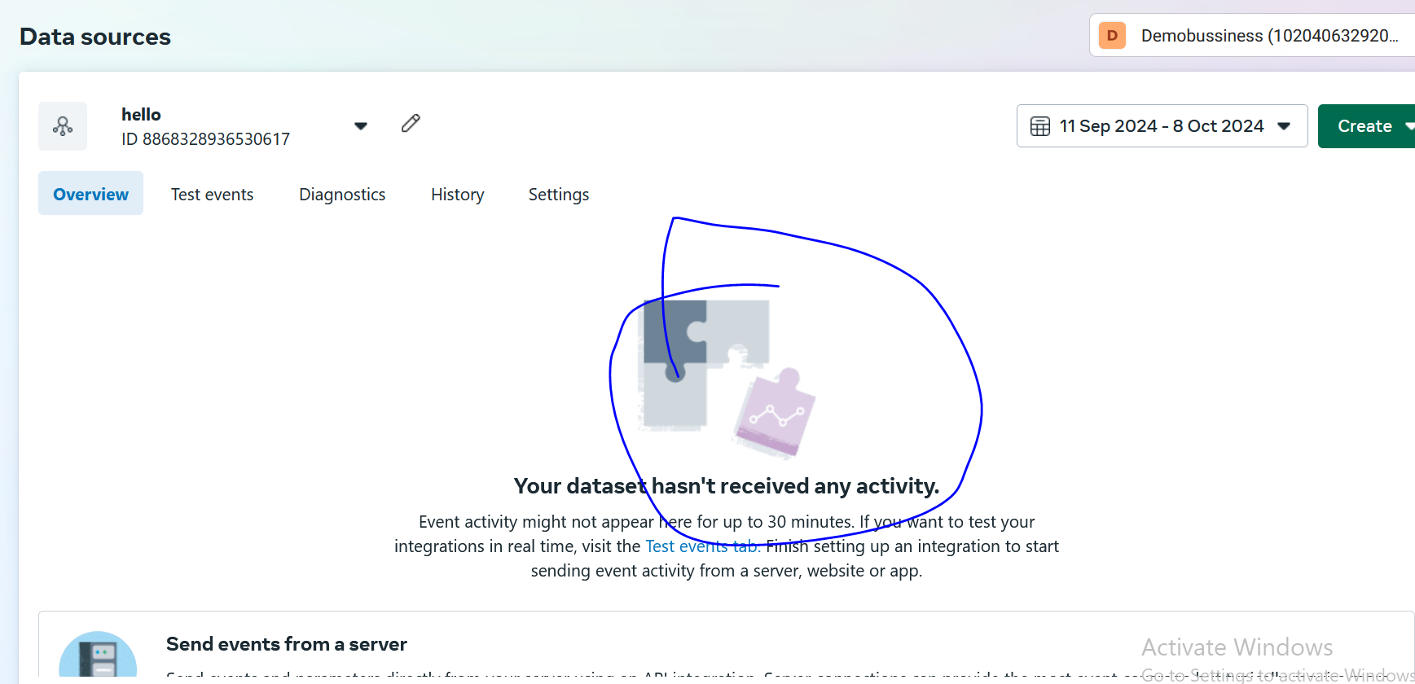

Once your pixel get installed with the website tghen you can show its data in the marked above

Like how many visitors are coming and then page views and other things as well

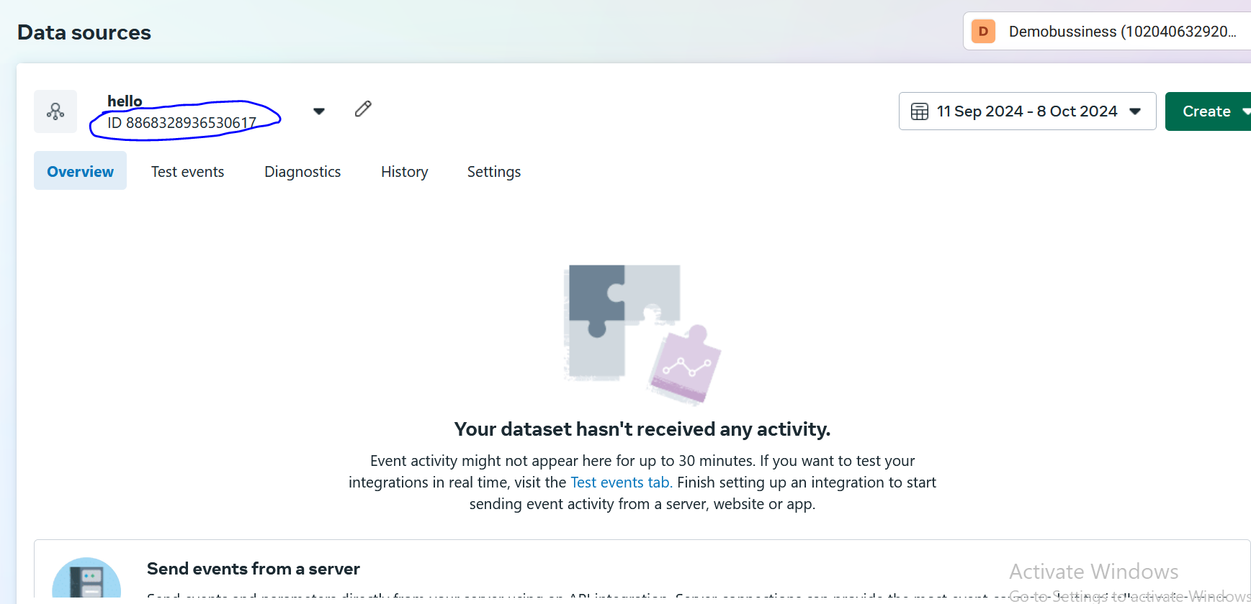

Now you can see the id in above marked area

Lesson 40:-

In this lesson we will learn about How to create Fcebook Event.

Lets say if we want to create an audience of people who have clicked in a button in our website so how can we do it

As we know we can do so with the help of pixel

But the base pixel can only track page view

But we can track the button click or download of something

So if we have some specific requirement like whoever click on any specific button I want to make it audience then we need to make this interaction as an event by configuring it or create it

So here we are talking about ow to create an event through facebook pixel in facebook ad account

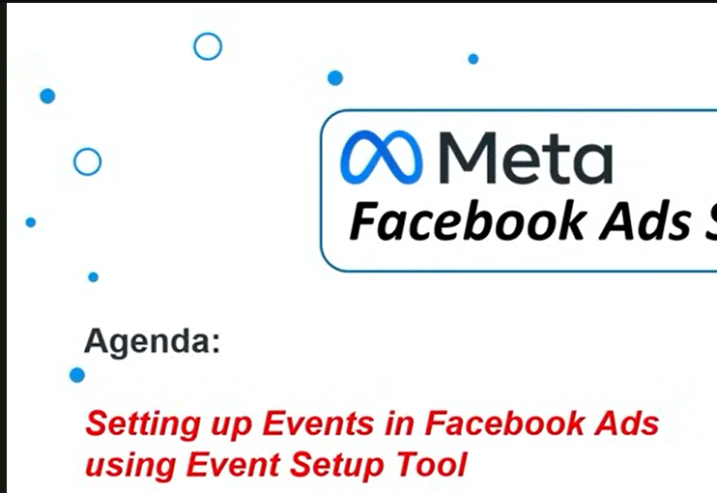

First we open a website on the basis of which we are going to create an event

And there are different ways to create an event the first way is

The first and very easy way is to use event setup tool that we will find in facebook and through it how can we create an event

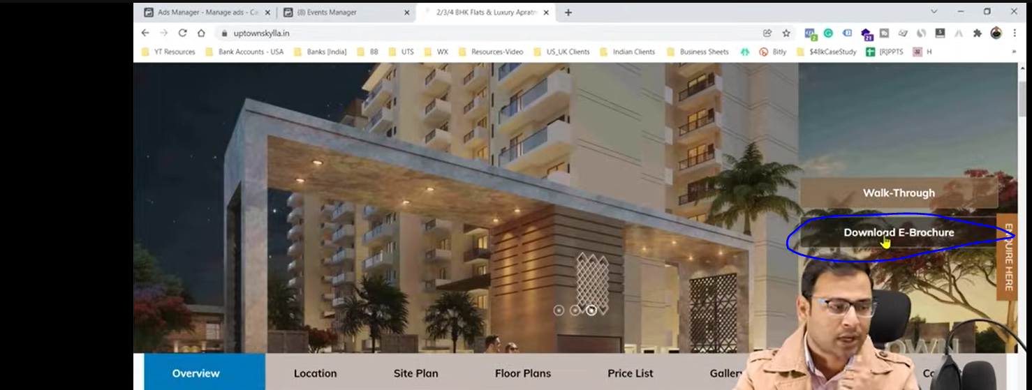

Now the teacher want to track those people who have clicked on the button as marked above

Now go to Event Manager then you will see that your pixel is capturing some data that you have already set in your website that you can see as marked below

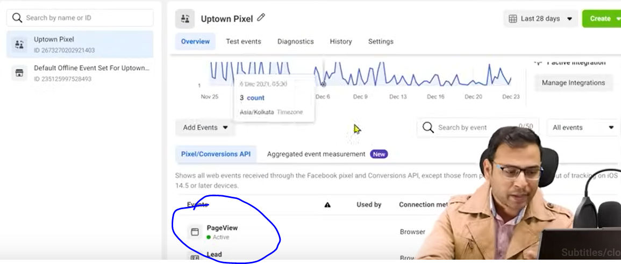

Now our pixel is actually capturing the pageview as an event which by default capture it. If you have not done any additionalsetting then it will still capture it.

You can see there u=is an event lead configured by the teacher

**Note:-**

I think whatever the teacher is trying to do will work once the pixel is tracking some data from the Website

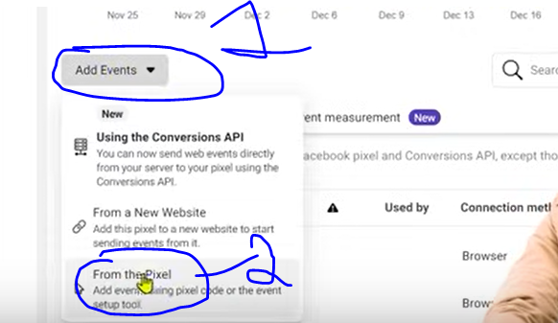

Now in Data source overview in events manager

Below the dat shown click on add events button and then in submenu click on Fro the pixel option

And then a mini window will be opened like this

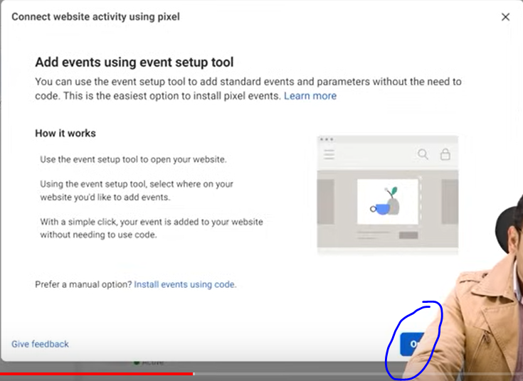

Now clikc on Open events setup tool button as maked above

As teacher said that there are other way to set up events

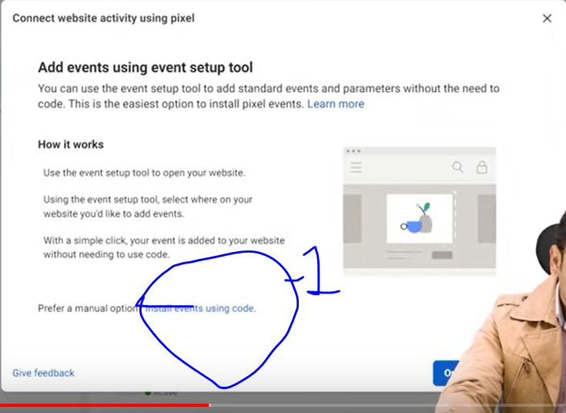

We can do so by clicking on the 1 marked above while avoid clicking on open event setup button here we are setting up our event by event code

We can take events code from there and fire them we can do so but we will do it later.

But we will only use event setup tool so we will click on open setup event button

And the a mini window will be opened like below

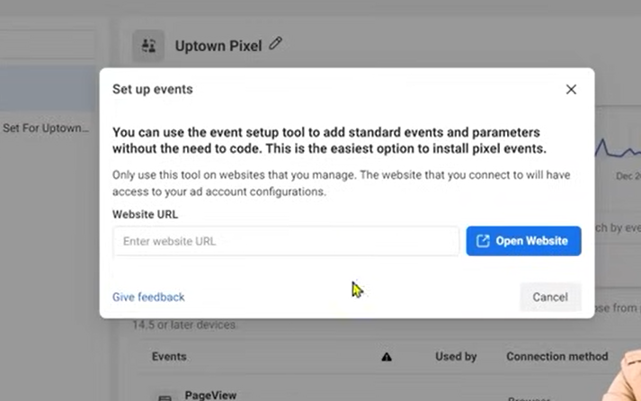

Now in textfield type the url of website you want to connect it with your pixel.